

INFORMATION TECHNOLOGY

ESSENTIALS LABORATORY

(IT5211)

# MINI PROJECT

**HOSTEL STORE ONLINE BOOKING SYSTEM**

**ONLINE BOOKING SYSTEM**

Name: Babu M

Reg No: 2022506095

Subject Code: IT5211 Semester: 2/8

Submitted to: Mrs **M. Hemalatha**

Date of Submission: .07.2023

**INTRODUCTION**:

The Hostel Store Online Booking System is a mini project developed using HTML, CSS, JavaScript, and PHP. The purpose of this project is to create a web-based platform that allows users to order and book items from the hostel store, similar to popular online food delivery platforms like Zomato and Swiggy. The system aims to streamline the ordering process for hostel residents, making it convenient and efficient.

**TECHNOLOGIES USED**:

The mini project utilizes the following technologies:

a) HTML:

HTML (Hypertext Markup Language) is used for structuring the web pages, defining the layout, and organizing content.

b) CSS:

CSS (Cascading Style Sheets) is used for styling the web pages, including colors, fonts, layouts, and overall visual presentation.

c) JavaScript:

JavaScript is used to add interactivity and dynamic behavior to the web pages. It enables features such as search functionality, real-time updates, and user input validation.

d) PHP:

PHP (Hypertext Preprocessor) is used as the server-side scripting language. It handles user authentication, manages data from the database, processes transactions, and generates dynamic web pages.

e) Database Integration:

For efficient storage and management of data related to products, users, orders, and other relevant information, the Hostel Store Online Booking System can integrate MariaDB as the database management system. MariaDB is a popular and robust open-source relational database that offers scalability, performance, and security. It provides the necessary functionality to handle data storage, retrieval, and manipulation effectively. With the integration of MariaDB, the system can ensure the seamless storage and retrieval of product details, user information, order records, and other related data, contributing to the overall functionality and reliability of the application.

**PROJECT COMPONENTS**:

The project consists of the following key components:

a) **User Interface**:

The user interface will be developed using HTML and CSS. The index page will consist of a login page that differentiates between administrators and students.

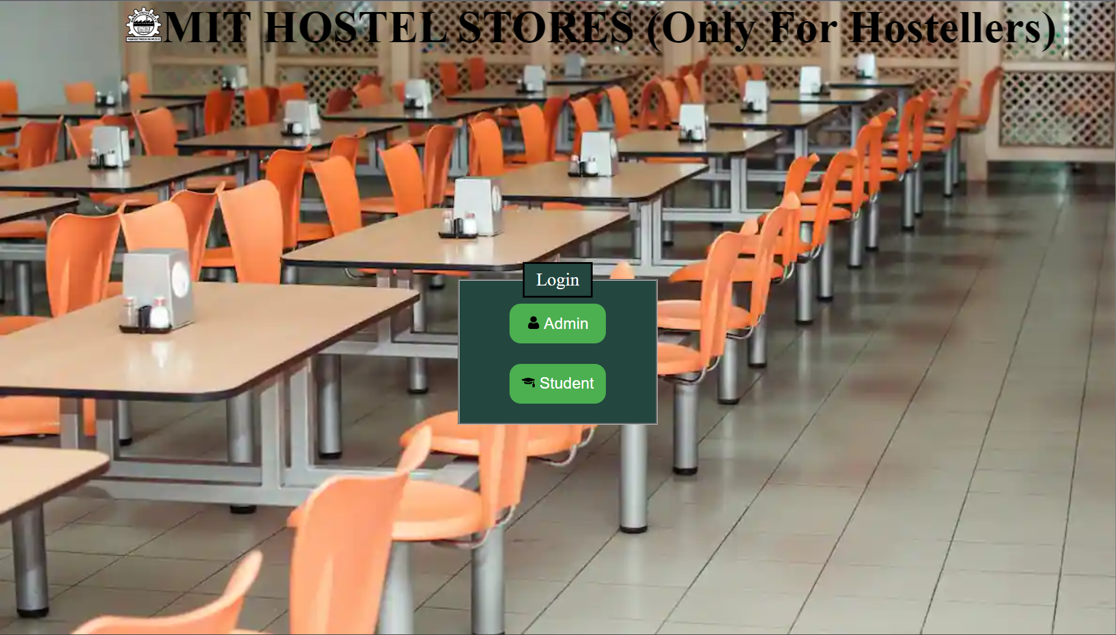

b) User Authentication:

The login page will allow administrators and students to enter their credentials and authenticate their access to the system. Usernames and passwords can be stored securely in the database.

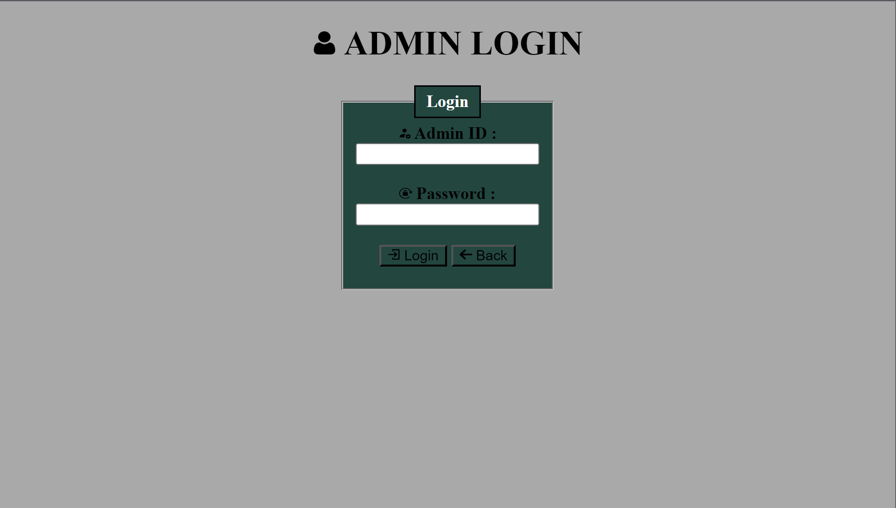

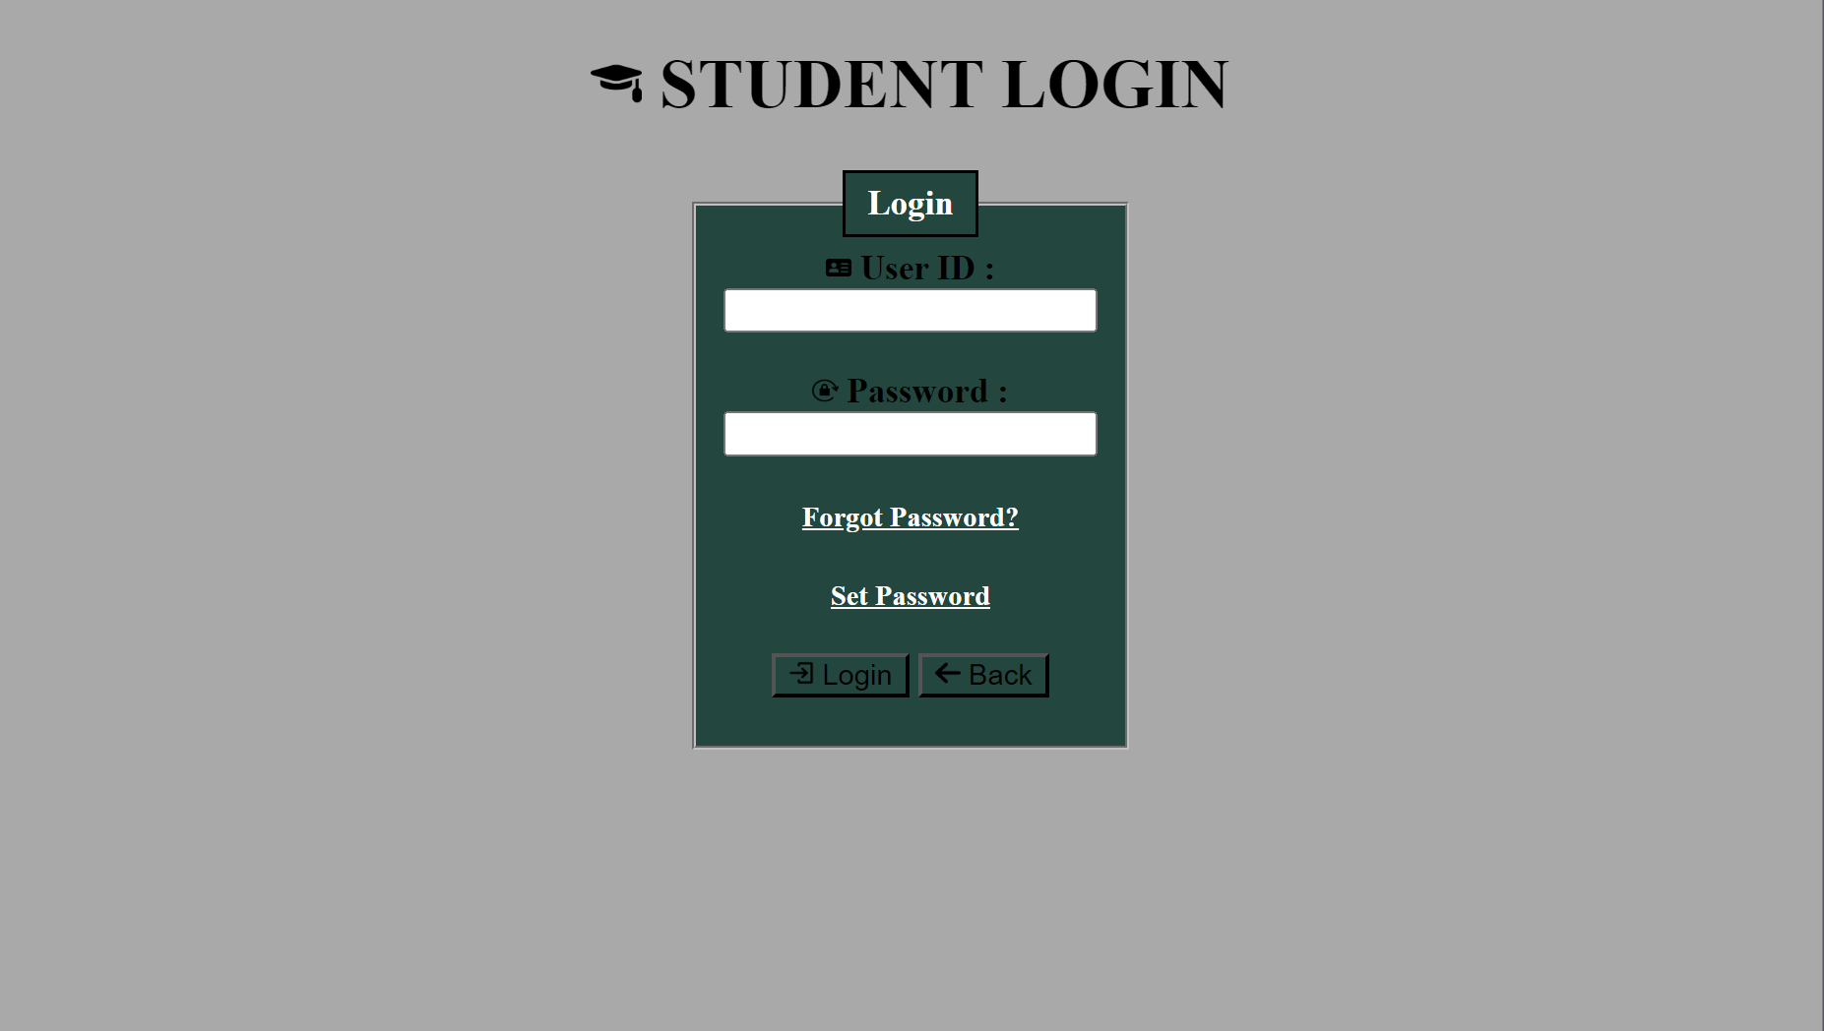

c) **Administrator Dashboard**:

Upon successful login, administrators will be redirected to their dashboard. The dashboard will provide them with administrative functionalities, such as managing product inventory, adding new items, updating prices, and monitoring orders.

1) ORDERS:

In the orders you can see the placed orders and order details. After packing an order is updated for delivery by clicking Packed button.

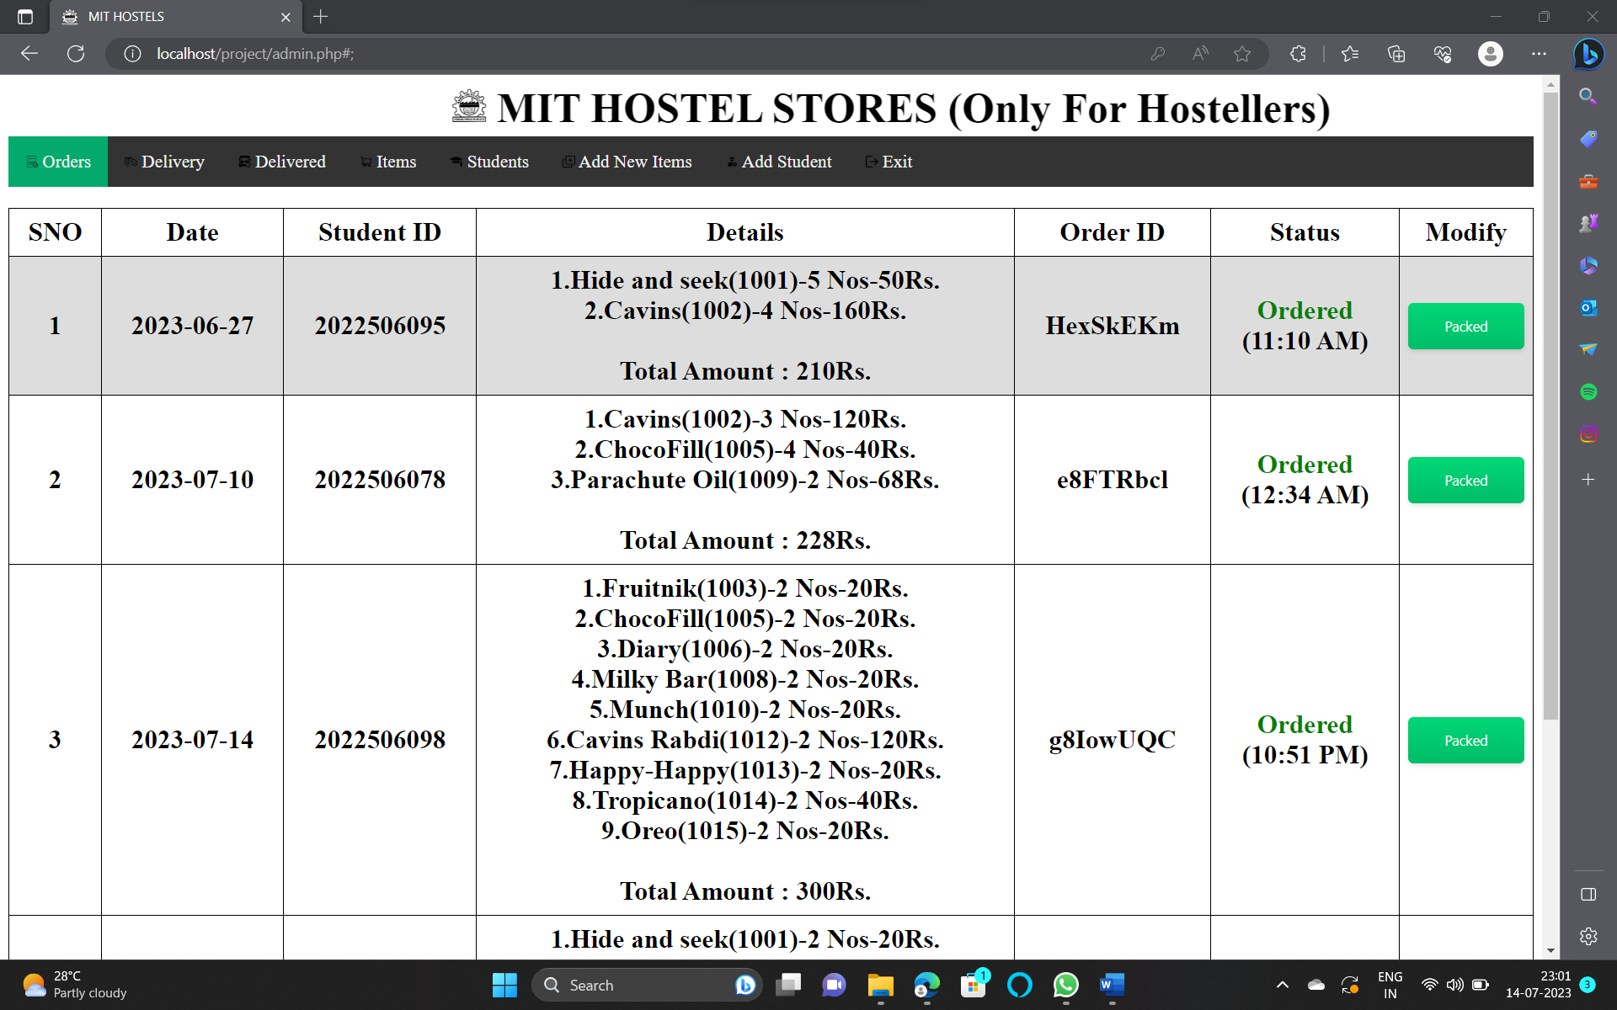

2) DELIVERY:

In the Delivery section you can see the orders that are available for delivery and their details.when a student come to store and tells his order ID the details will be taken seperately using search bar provided.After dispatching the order the statuss is updated to Delivered by clicking delivery button.

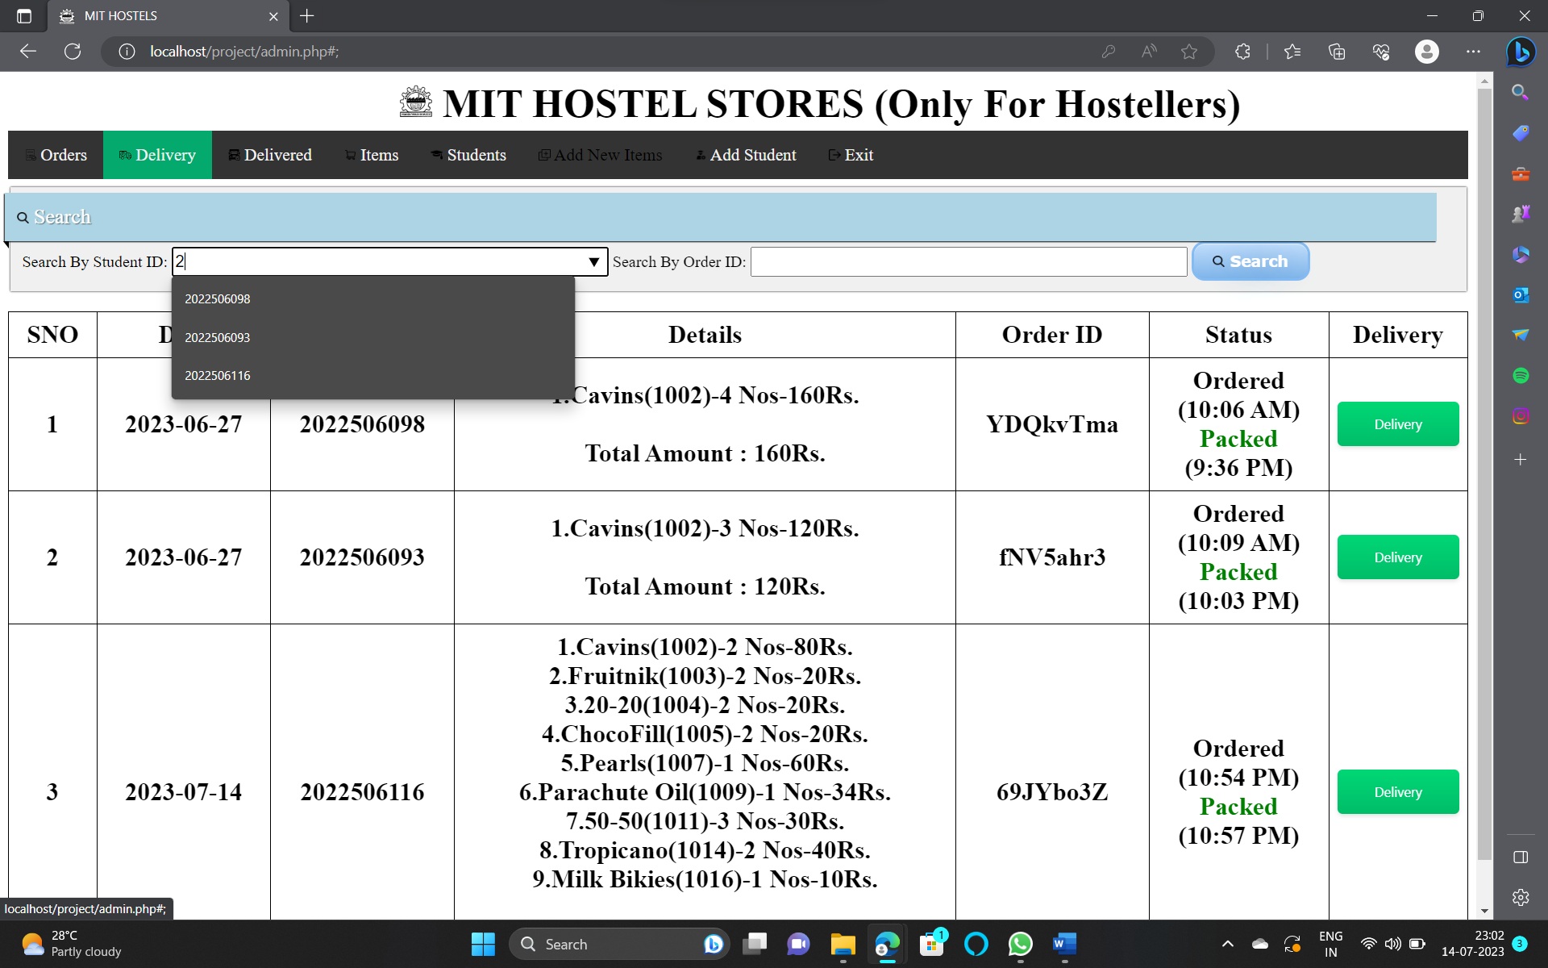

3) DELIVERED:

In the Delivered option you con see the old delivery history with their details like Delivered time, date, student ID etc…

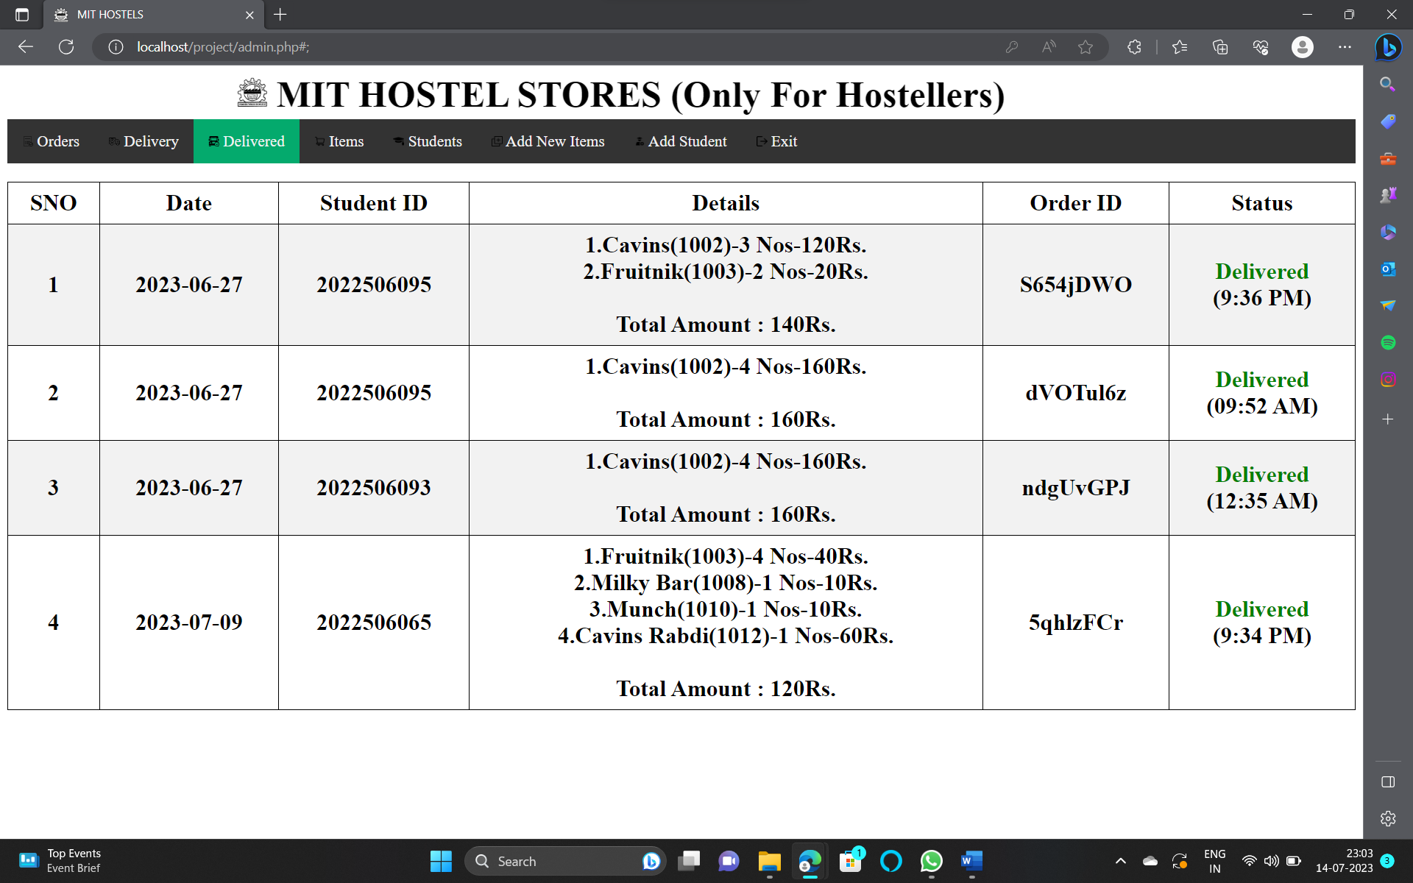

4) ITEMS:

In the Items you can see available items in the store you can update the availibility based on incoming stocks .You can also remove an item from a store by simply clicking delete button. You can also ssearch an item easily by using Item name or Item Code using provided Search Bar.

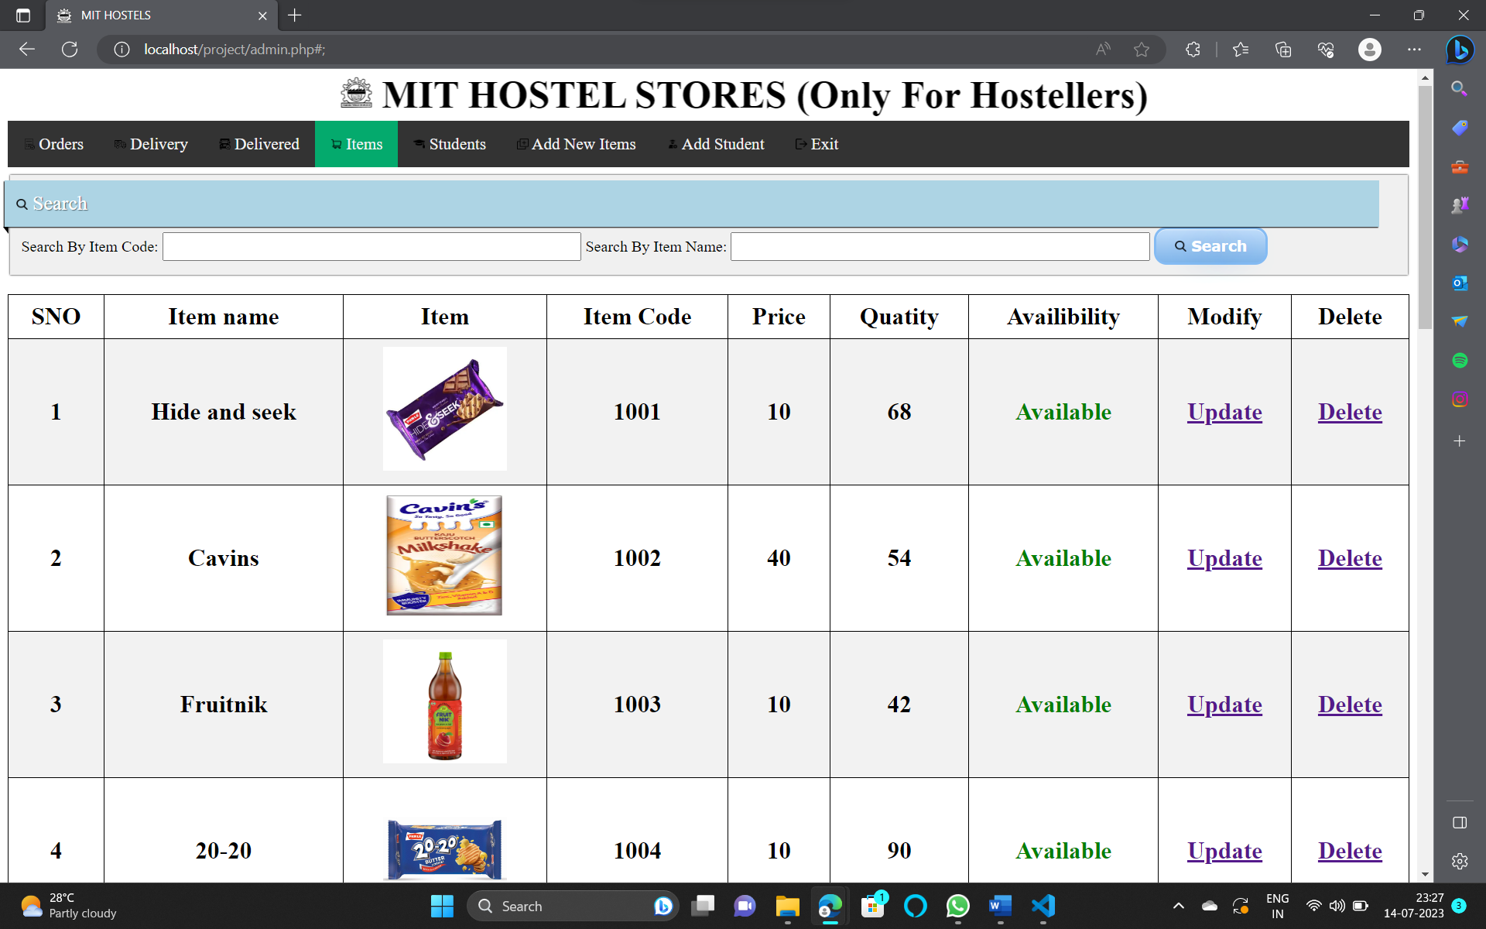

5) ITEM MODIFICATION:

After clicking the update button you allowed to add how many stocks that have received newly.After specifying the quantity you can update it by clicking update button.

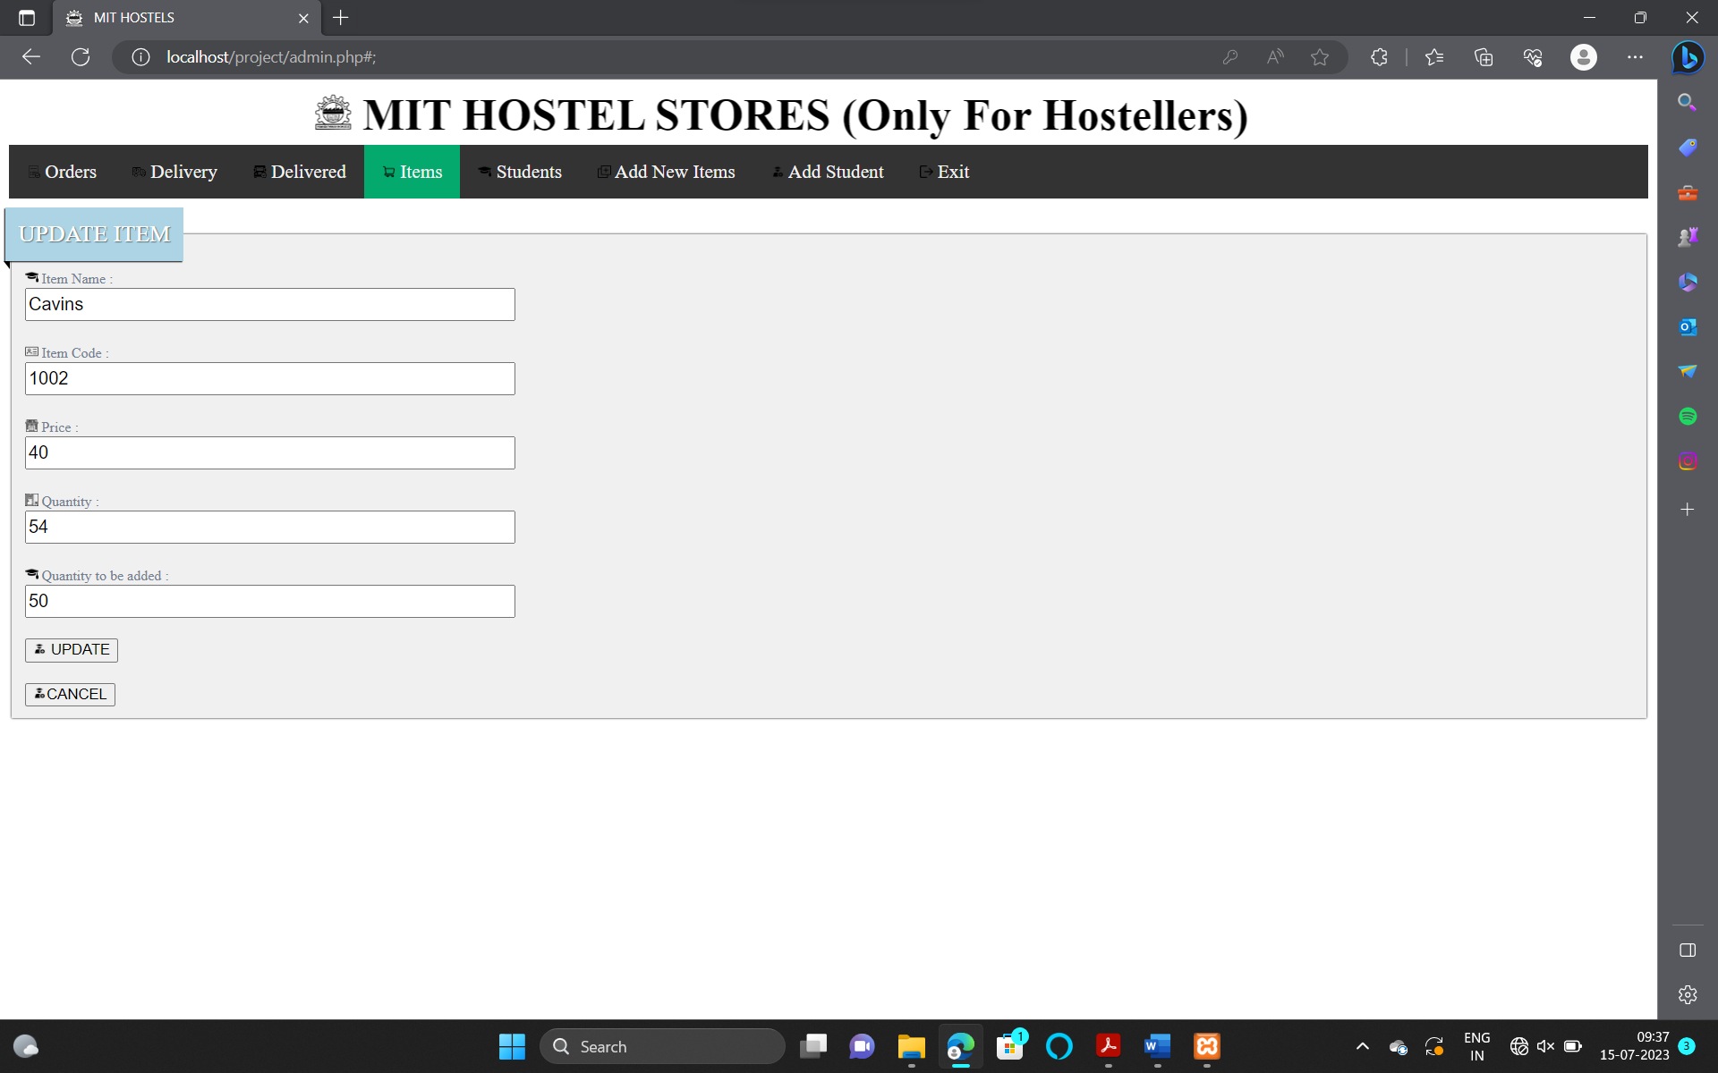

6) ITEM DELETION :

After clicking delete button the details about the item to be deleted will be displayed. After clicking the delete option the item will be removed from the store database.

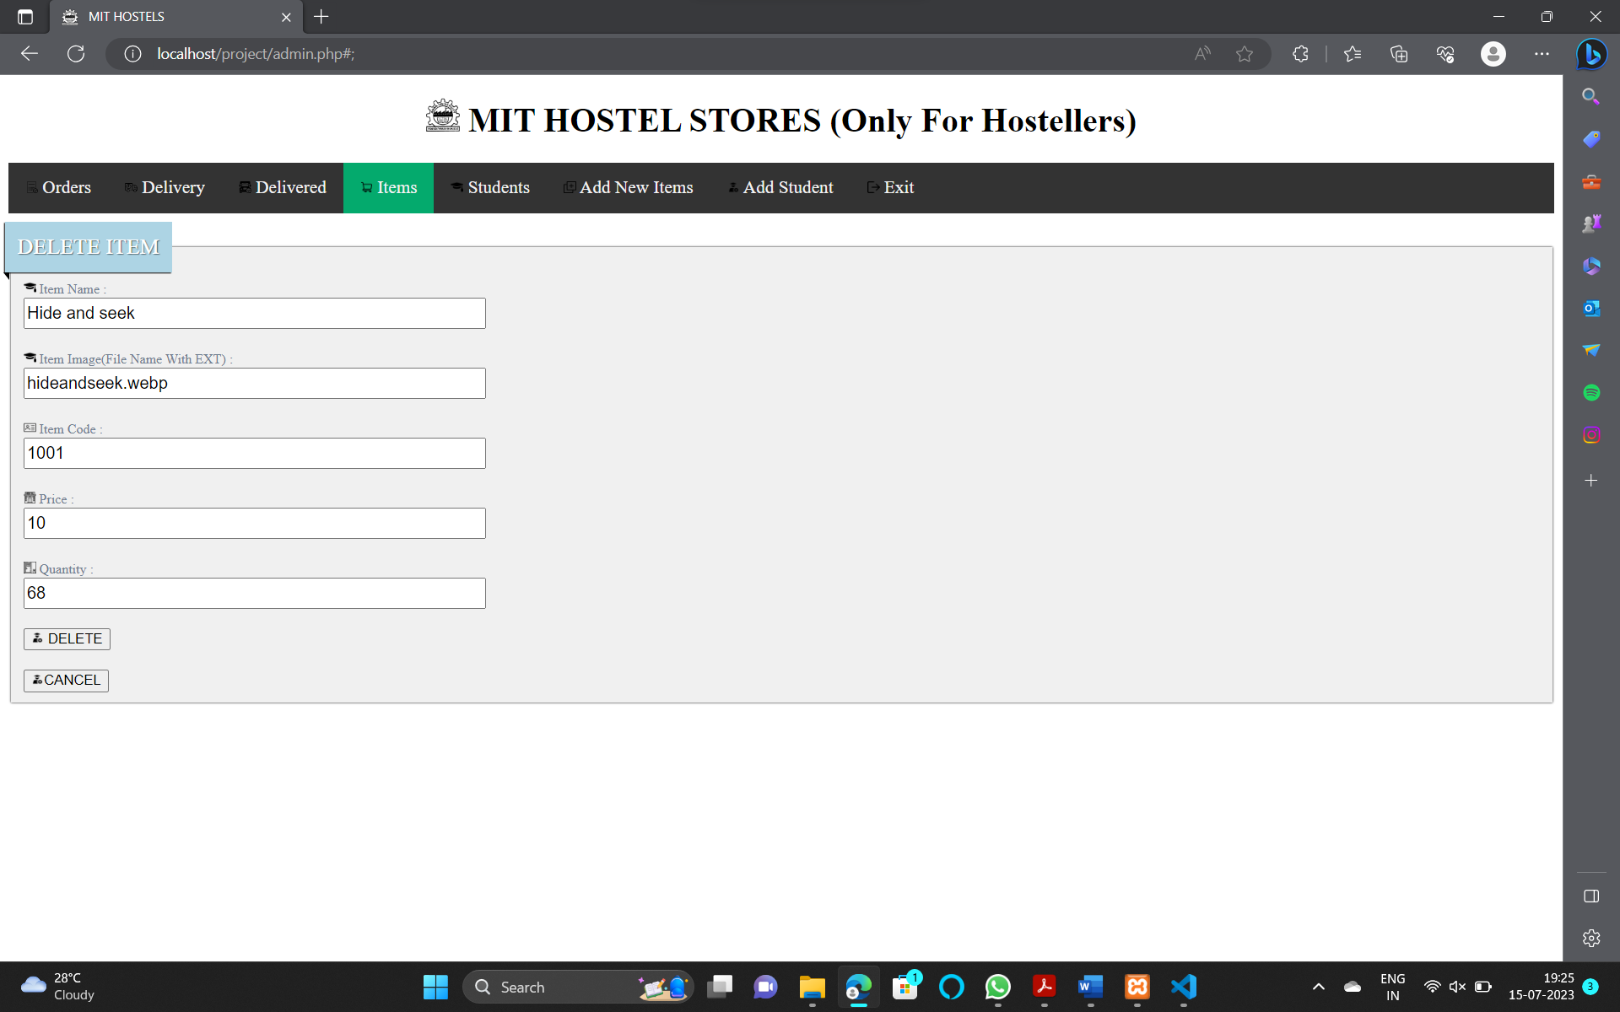

7) STUDENTS:

In the students option you can see the details (Hostel, Room No, Balance etc..) of all student you can also see a specific record by using student ID or Student Name using searching Bar. You can also update a student balance by using pay button and also delete a student record by clicking delete button.

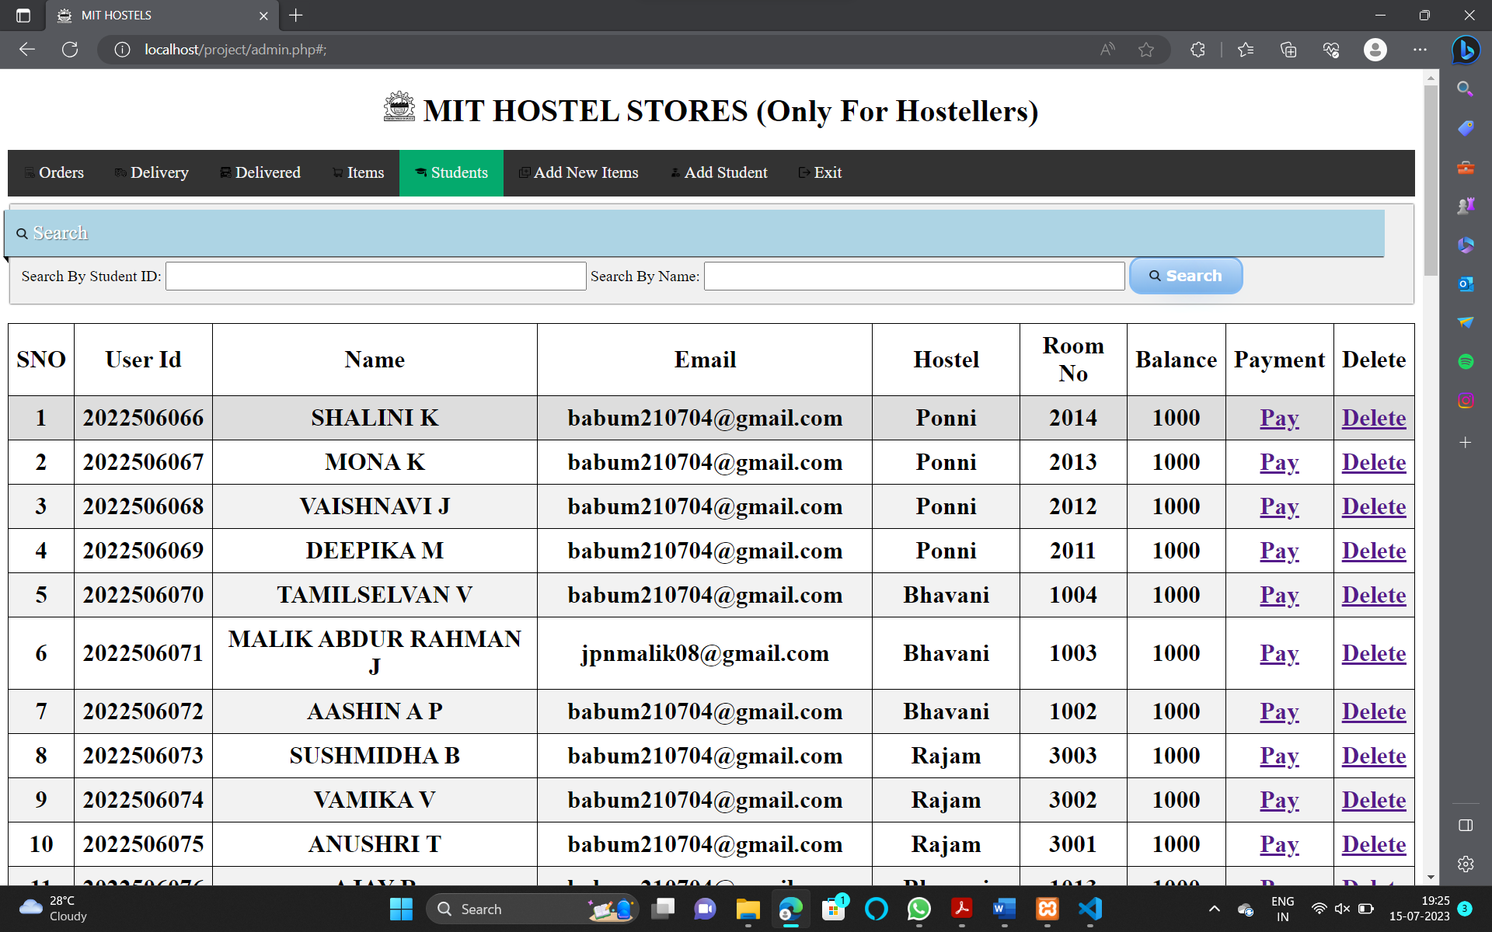

8) ADD PAYMENT:

By clicking the pay button student records whose balance to be updated will be displayed. After specifying amount to be added then after clicking update button the balance will be updated.

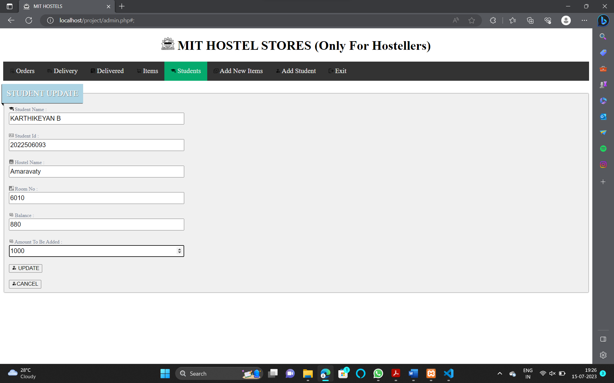

9) DELETE ACCOUNT:

By clicking the delete button the account to be deleted details will be displayed. After clicking the delete button student record will be completely deleted from the database.

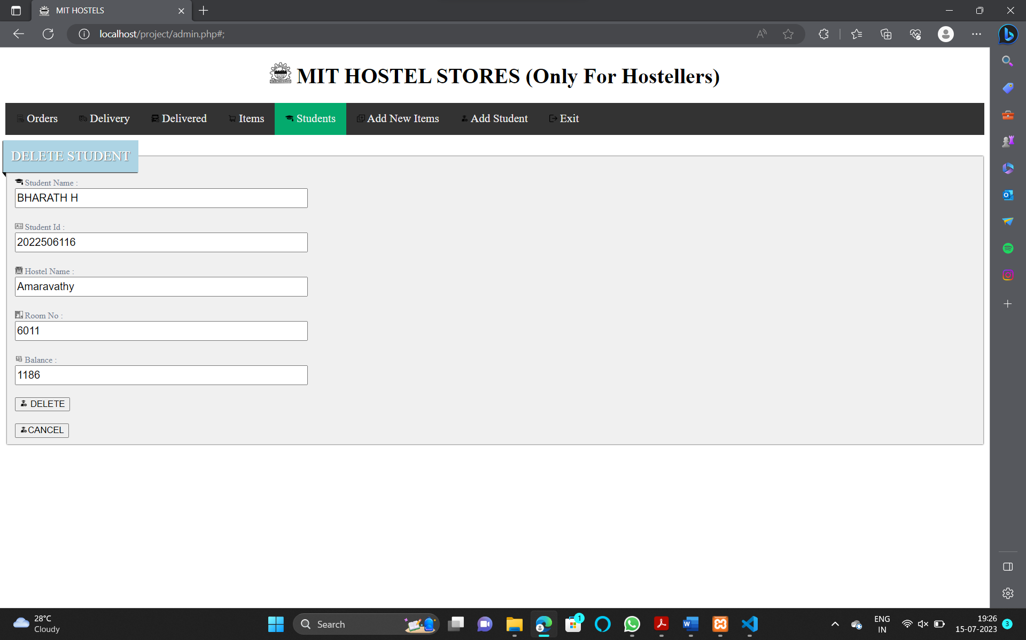

10) ADD NEW ITEM:

In the Add New Item option you can add a new item to the store by specifying it’s item name , item code, price and quantity.By clicking Add button the details will be updated in database successfully.

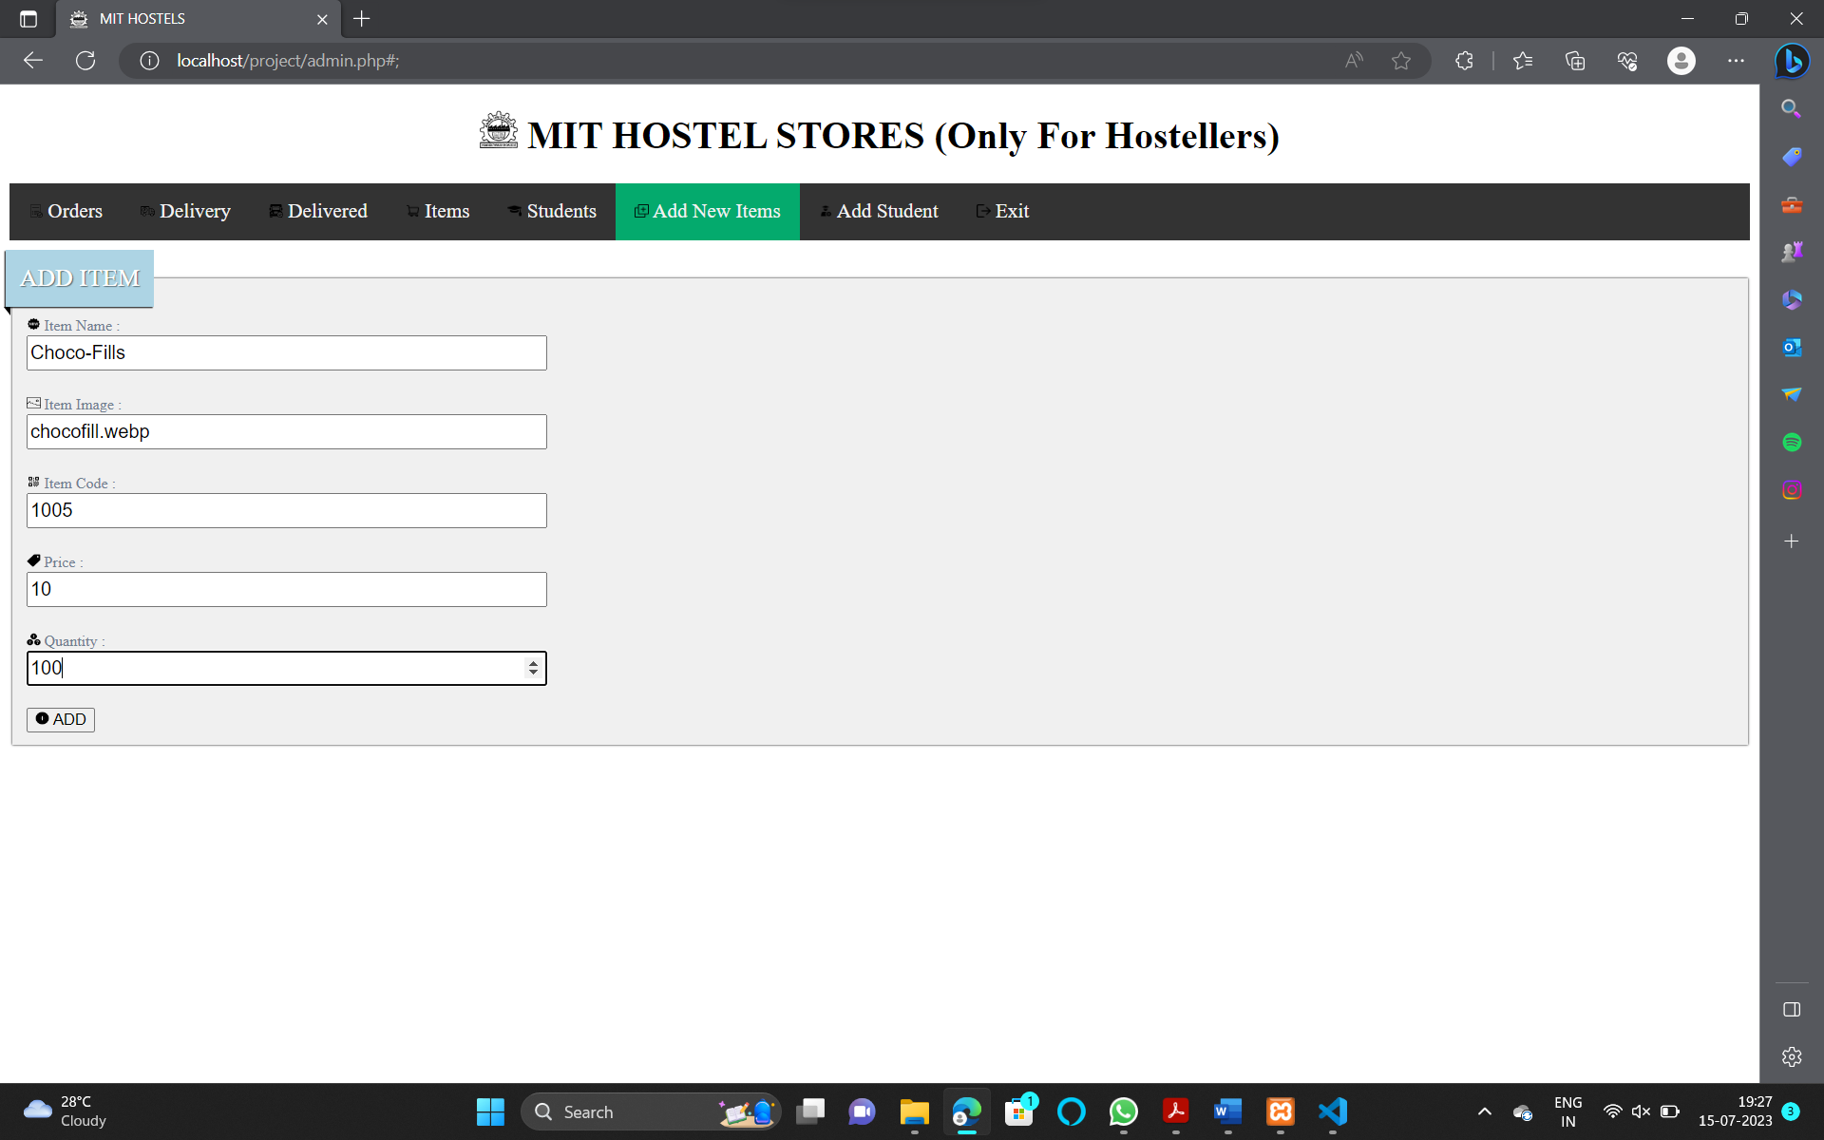

11) ADD STUDENT:

In the Add Student option you can add a new Student record by specifying Student name , ID , Hostel , Room No and Amount .By clicking Add button the details will be updated in database successfully.

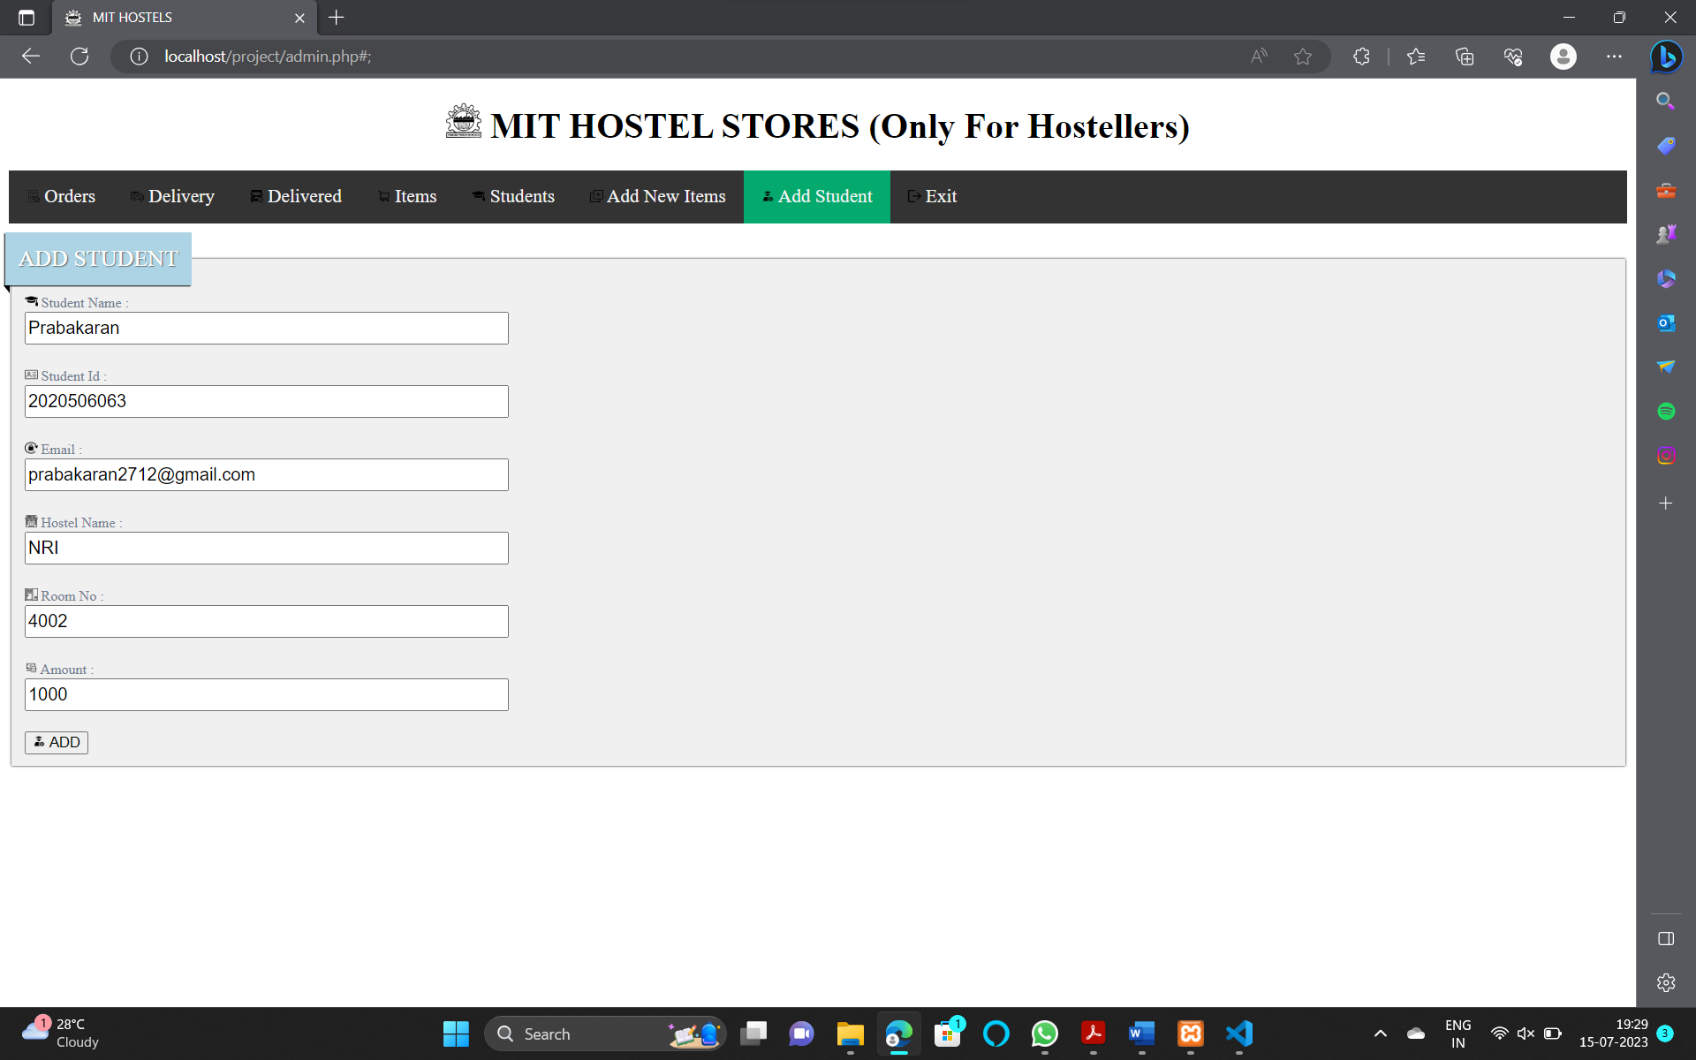

d) **Student Dashboard:**

After successful login, students will be directed to their dashboard. The student dashboard will provide options for browsing the hostel store's product catalog, adding items to the cart, and managing their orders.

1) PROFILE:

In the profile option you can see our details like student name , ID , Email , Hostel Name ,Room No etc…You can also change the Email ID by clicking Change Email button.

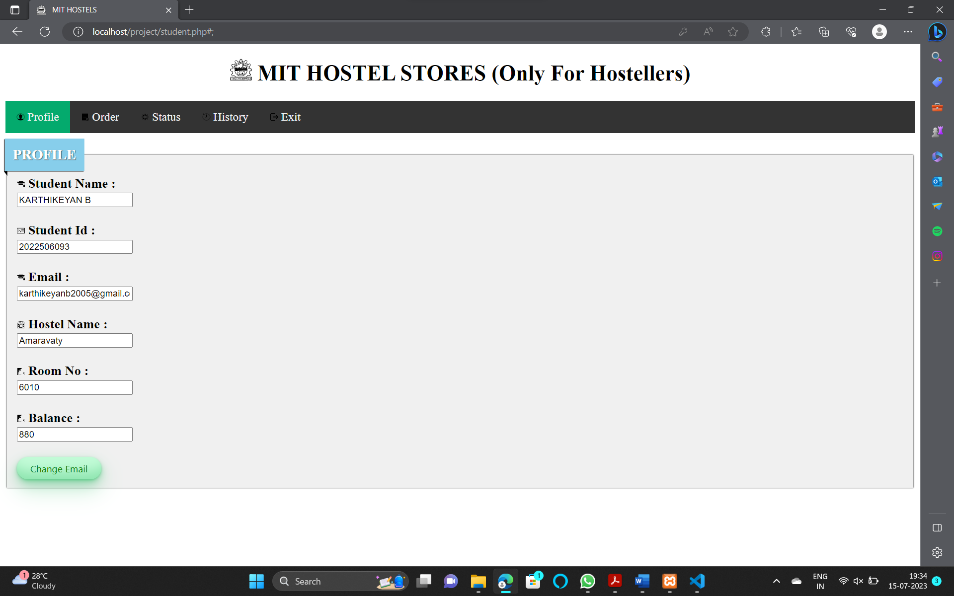

2) CHANGE EMAIL:

After clicking change Email button an OTP will be sent to the old Email ID. You are required to fill New Email ID and OTP .After clicking change button the Email ID will be updated in database successfully.

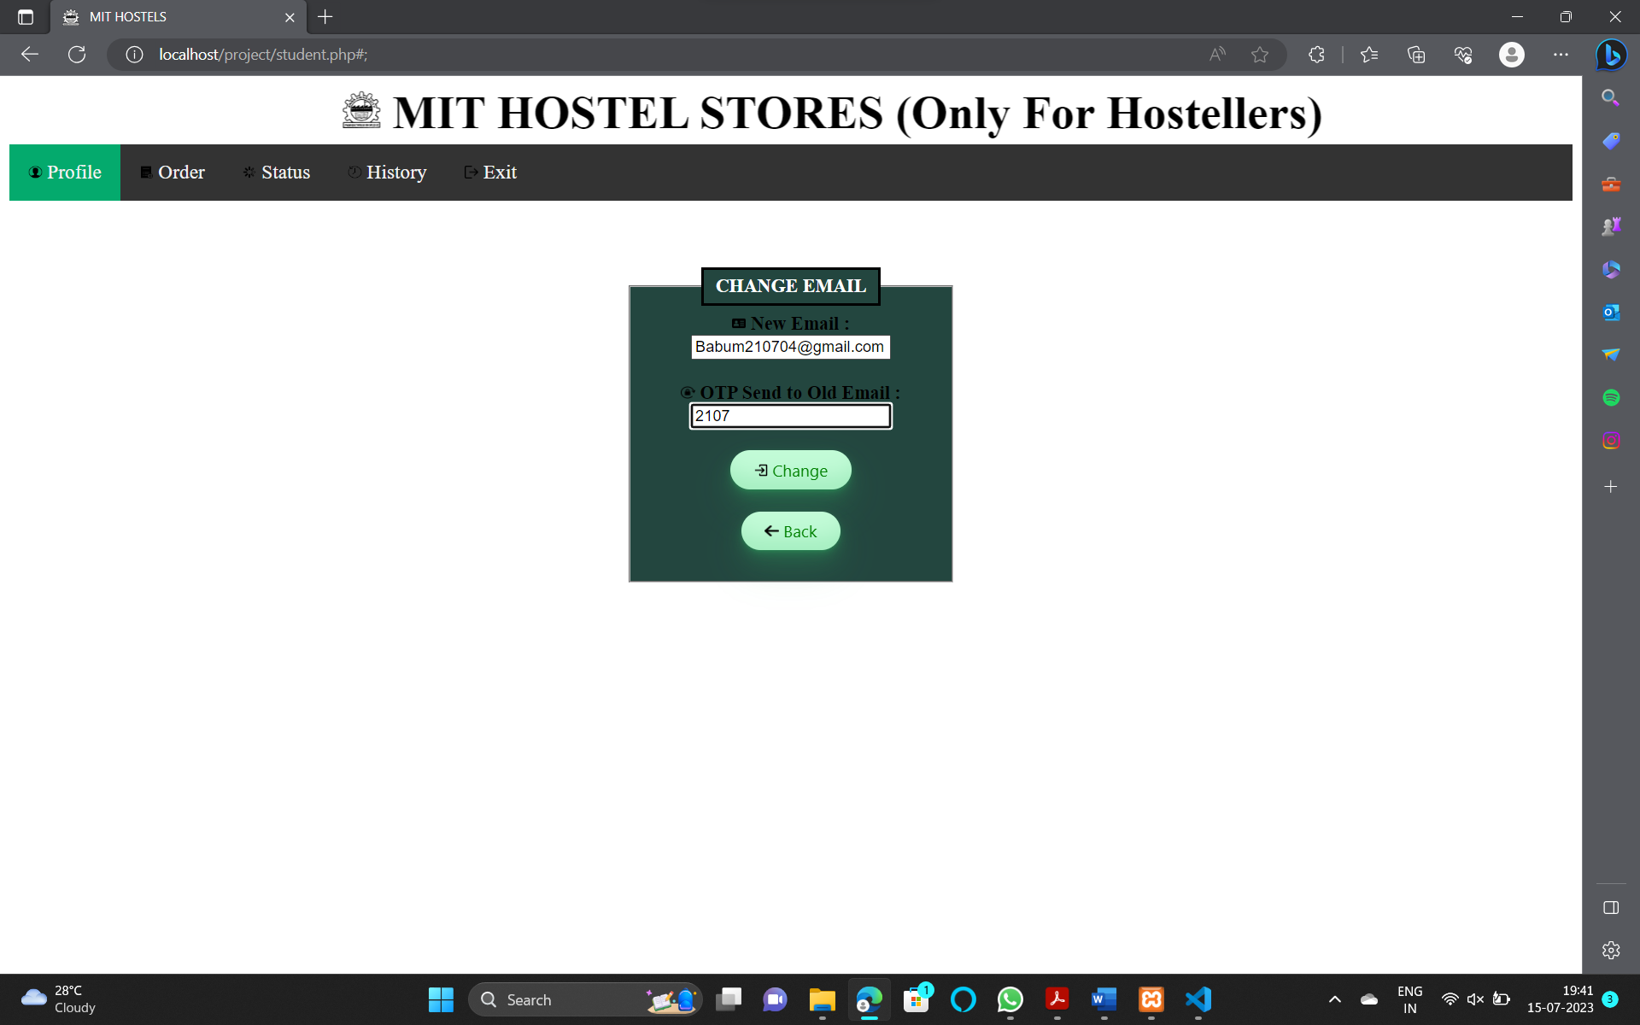



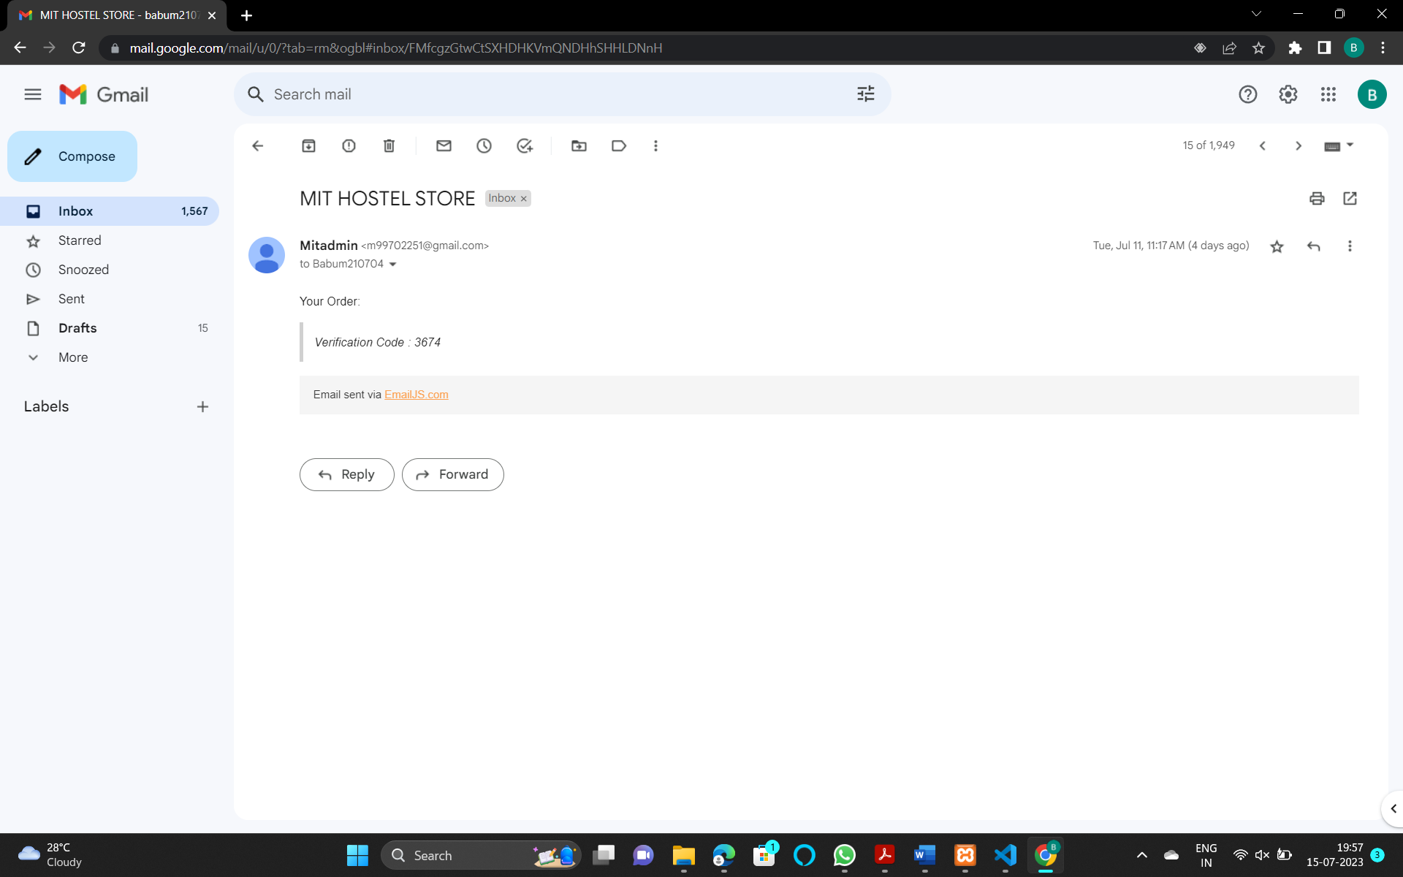

3) ORDER:

In the order option you can add the items to the cart that to be ordered. After selecting the item you need to press the buy button. After pressing the buy button a list of things that you have selected will be displayed after verifying the things press the order button an Email of your order will be sent to your respective registered Email.

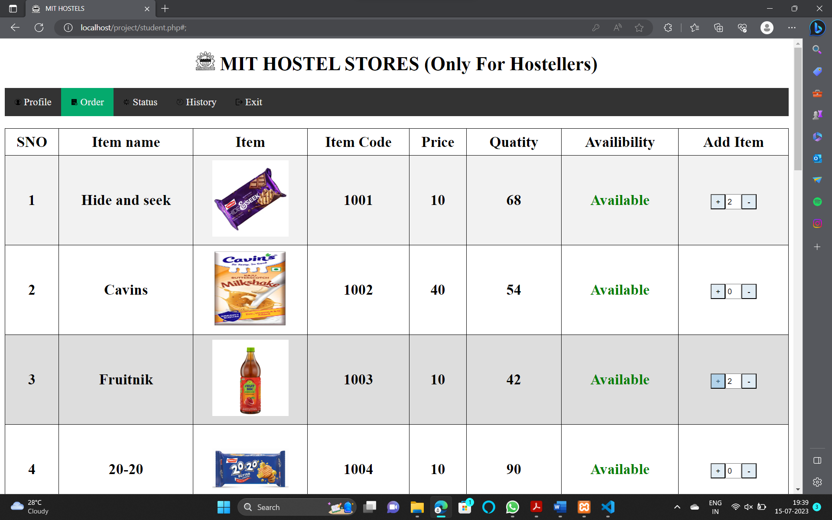

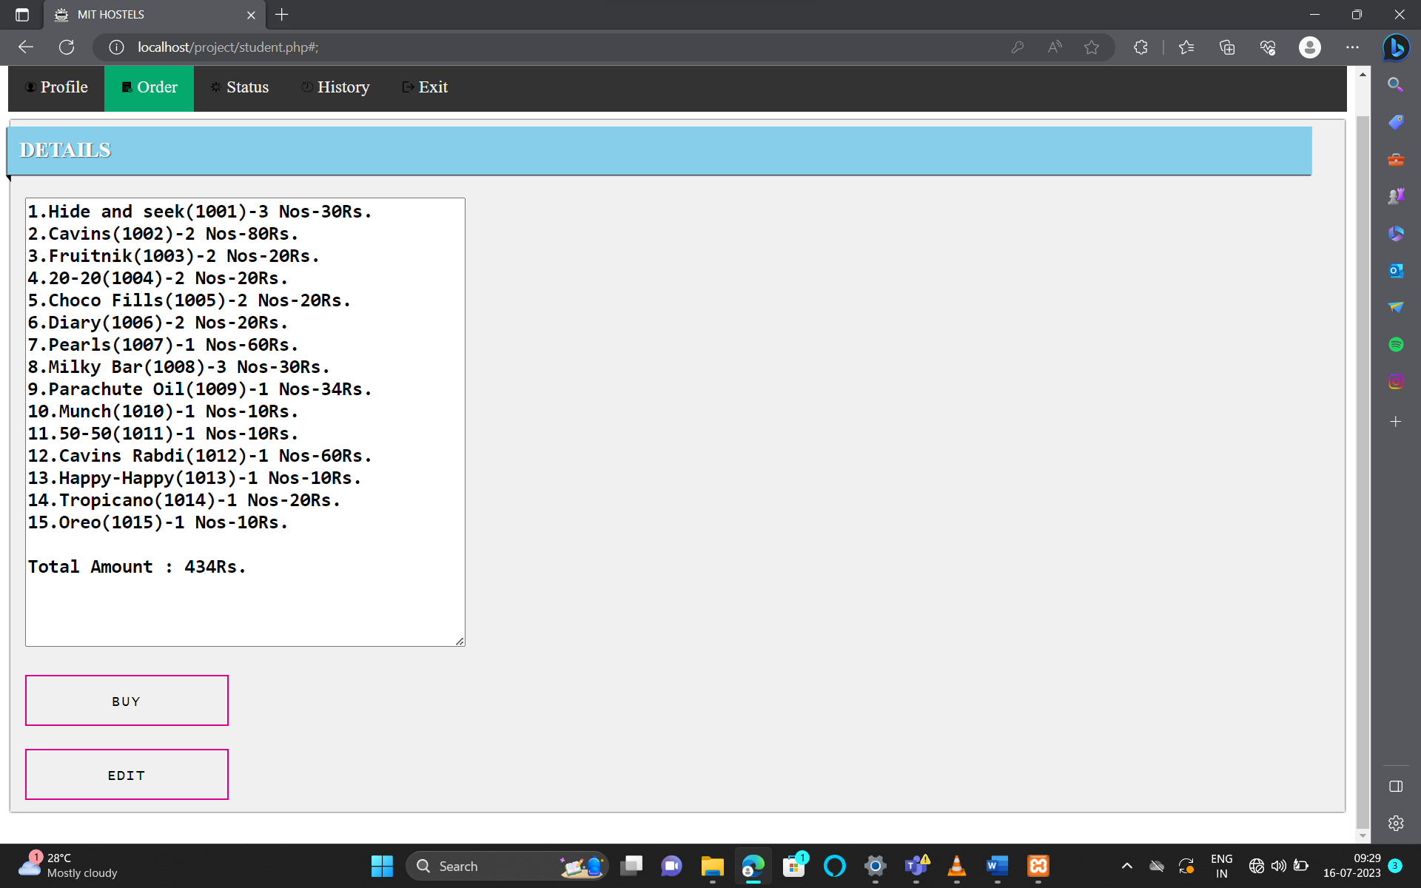

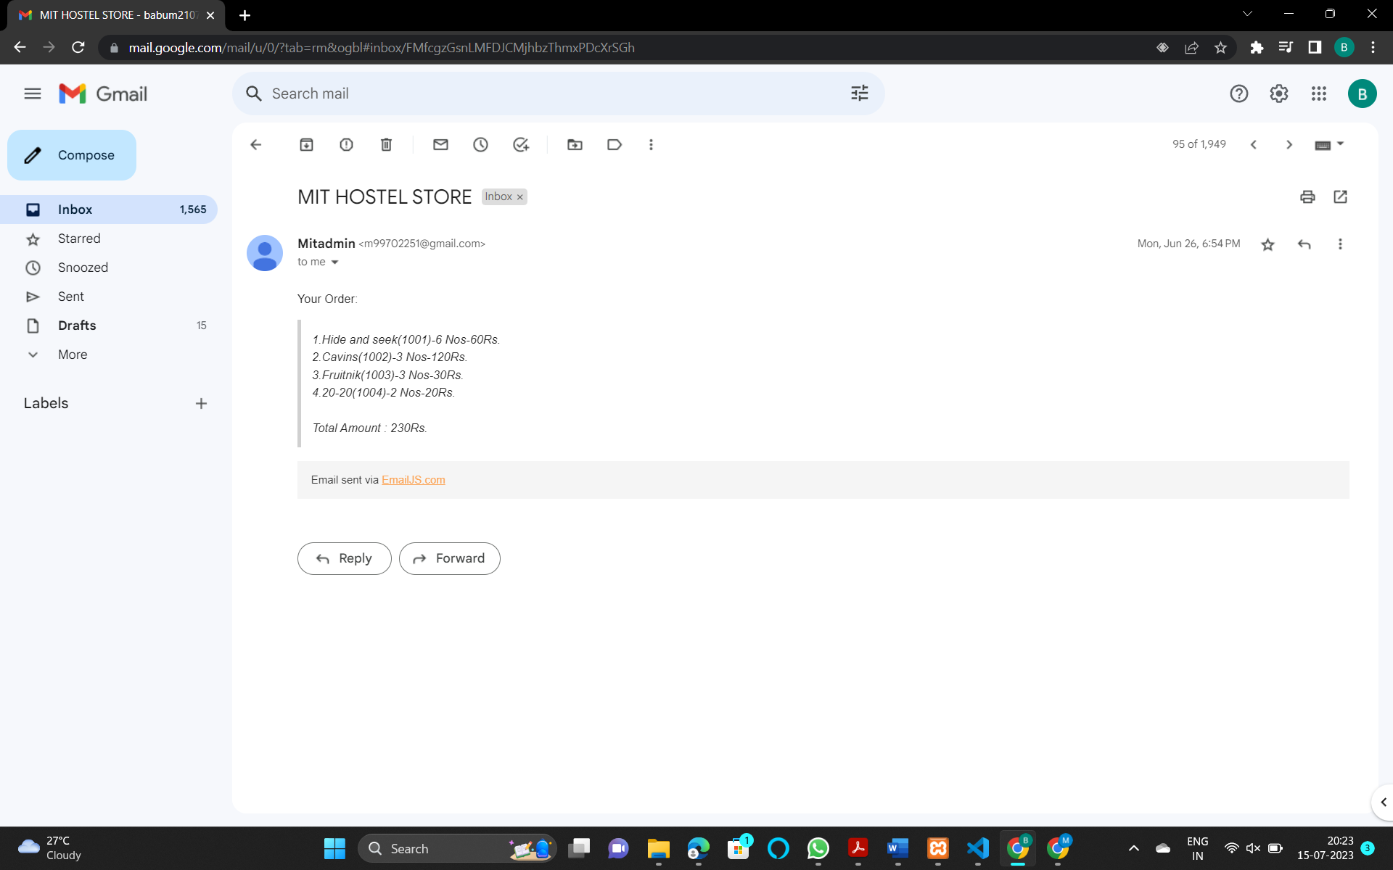

4) STATUS:

In the status option you can see the your current placed order their details like date, details, order ID, ordered and packed time.

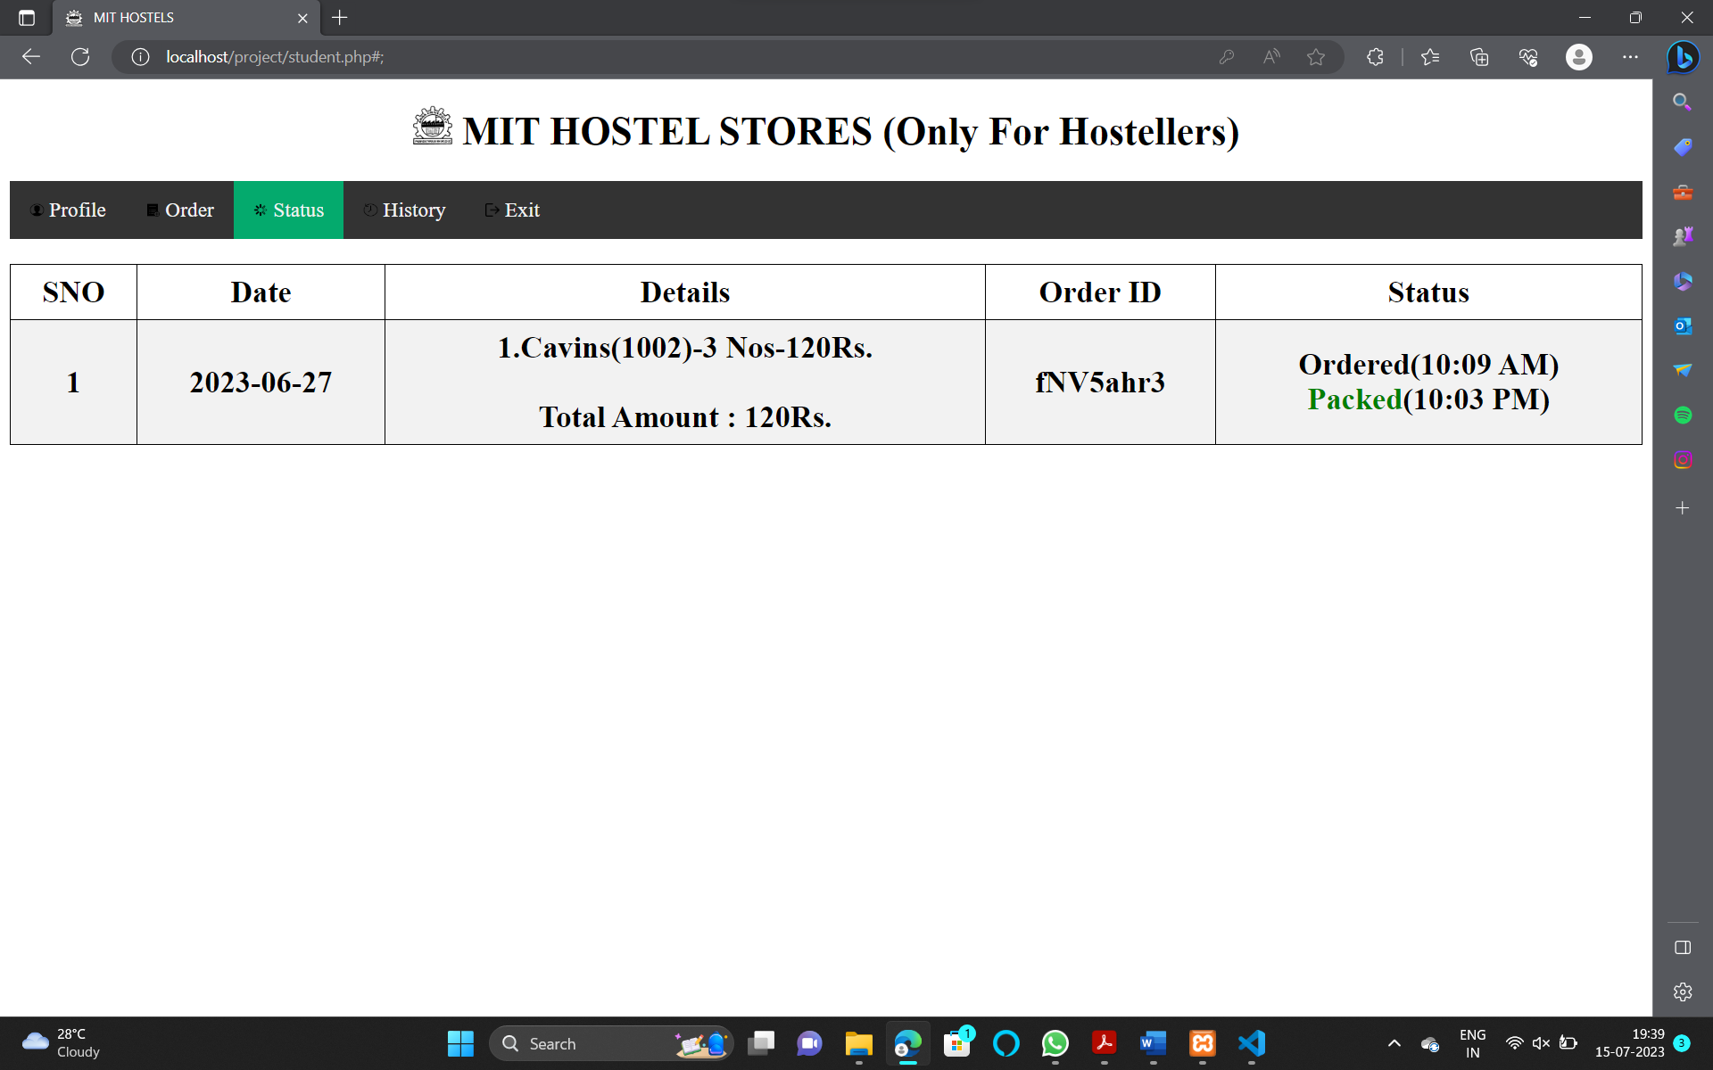

5) HISTORY:

In the history option you can see the details of your old orders like Date, Details, Order ID and Delivered time.

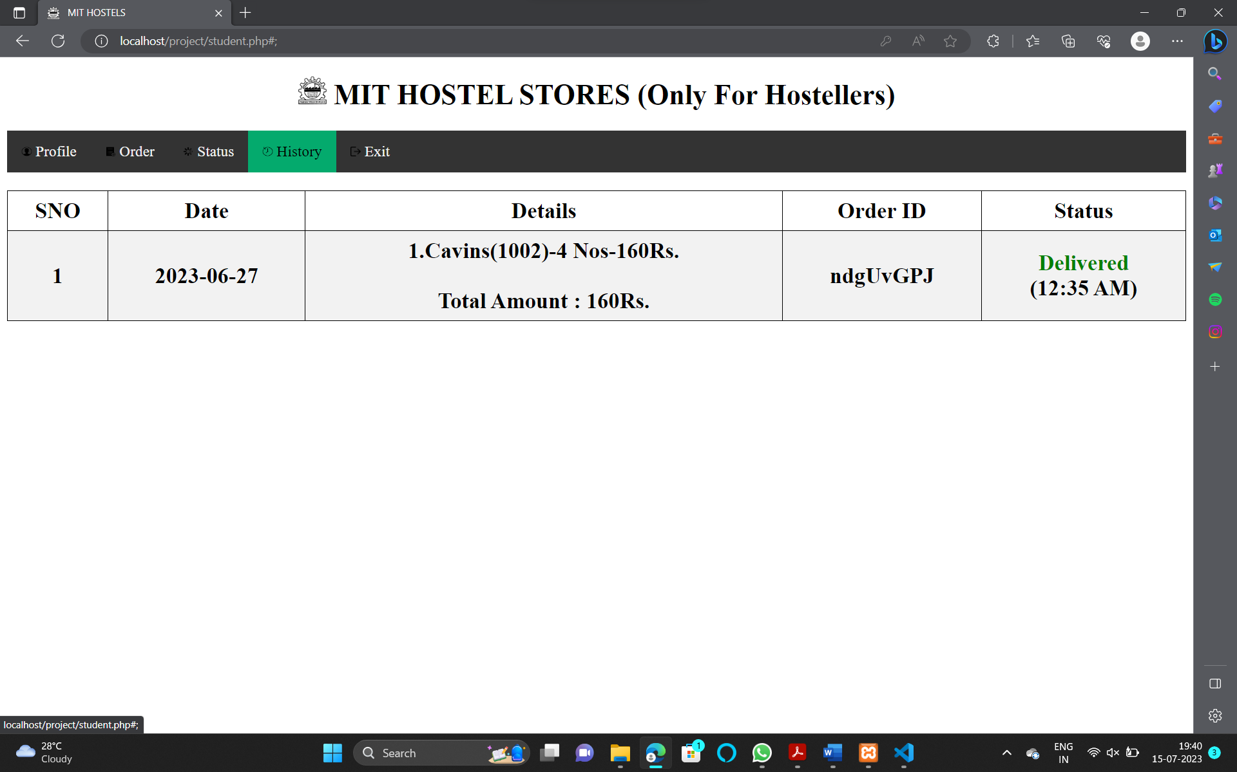

6) CHANGE PASSWORD:

In the login page you have an option to change password. After clicking change password button you will be allowed to type the student ID. After that an Email of the verification will be sent to your respective registered Email.

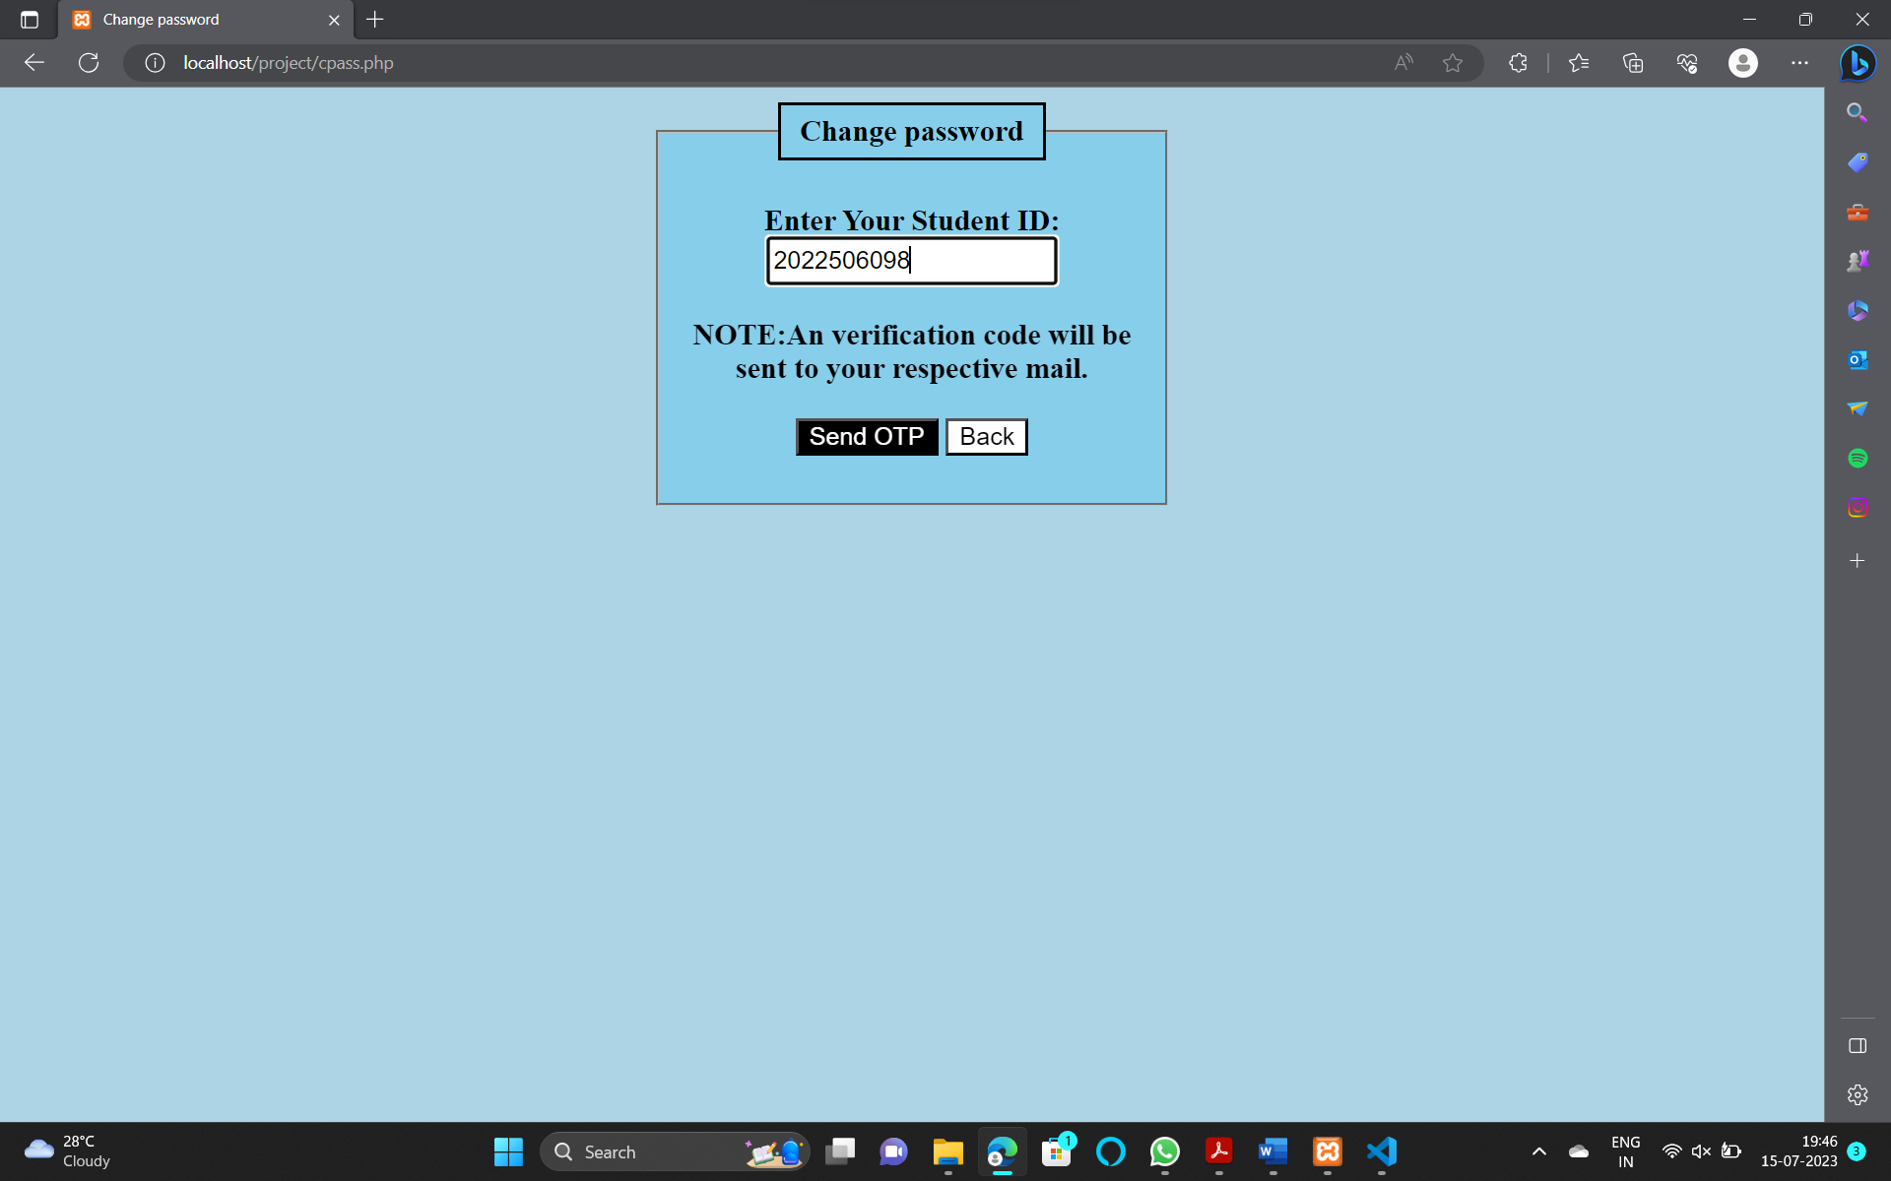

i) OTP VERIFICATION:

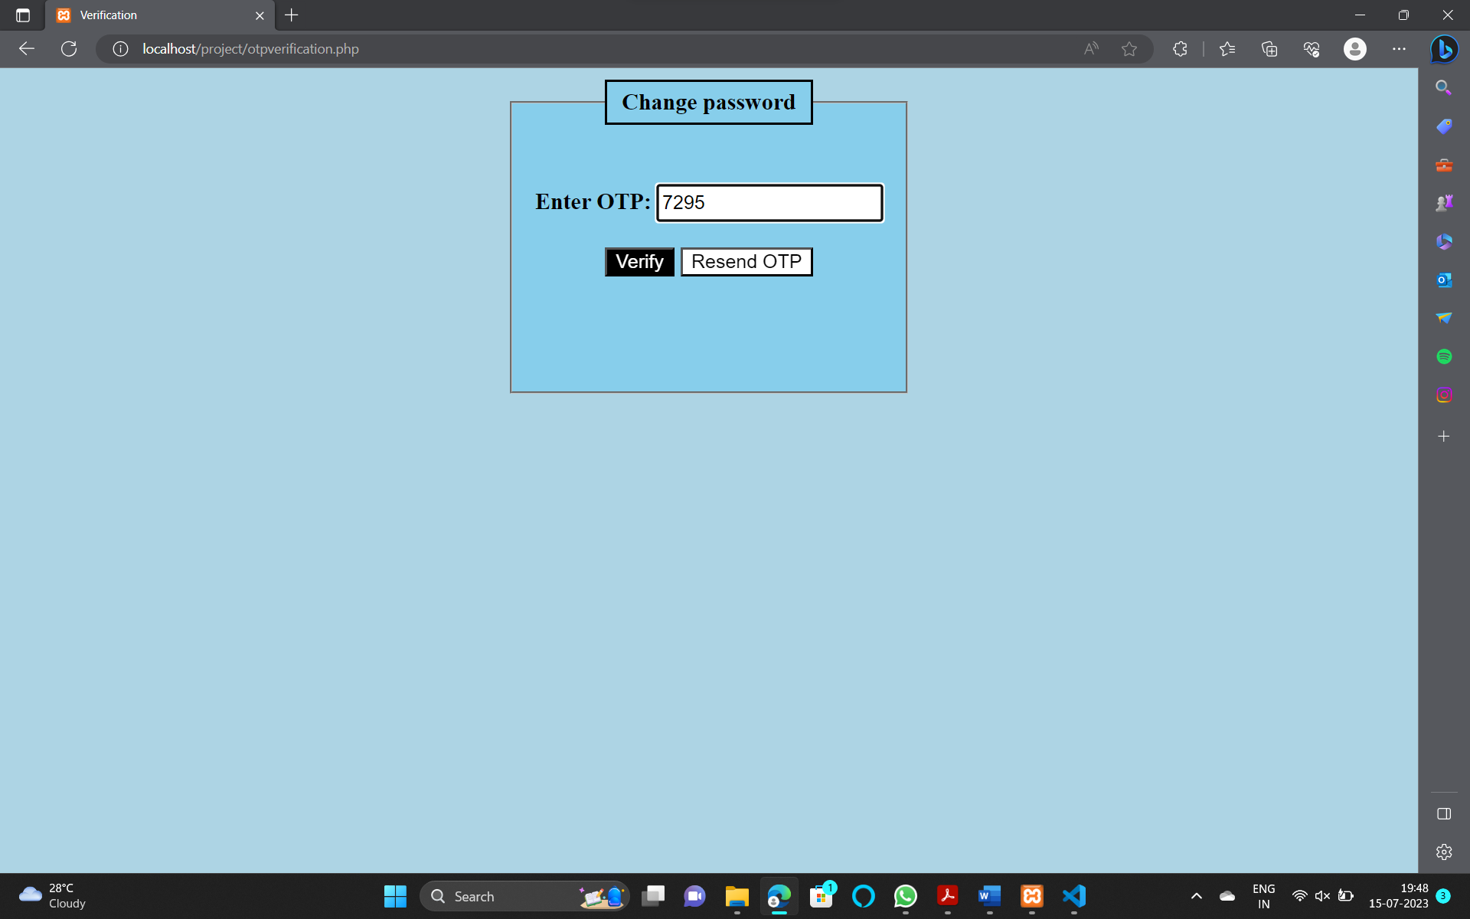





ii) NEW PASSWORD:

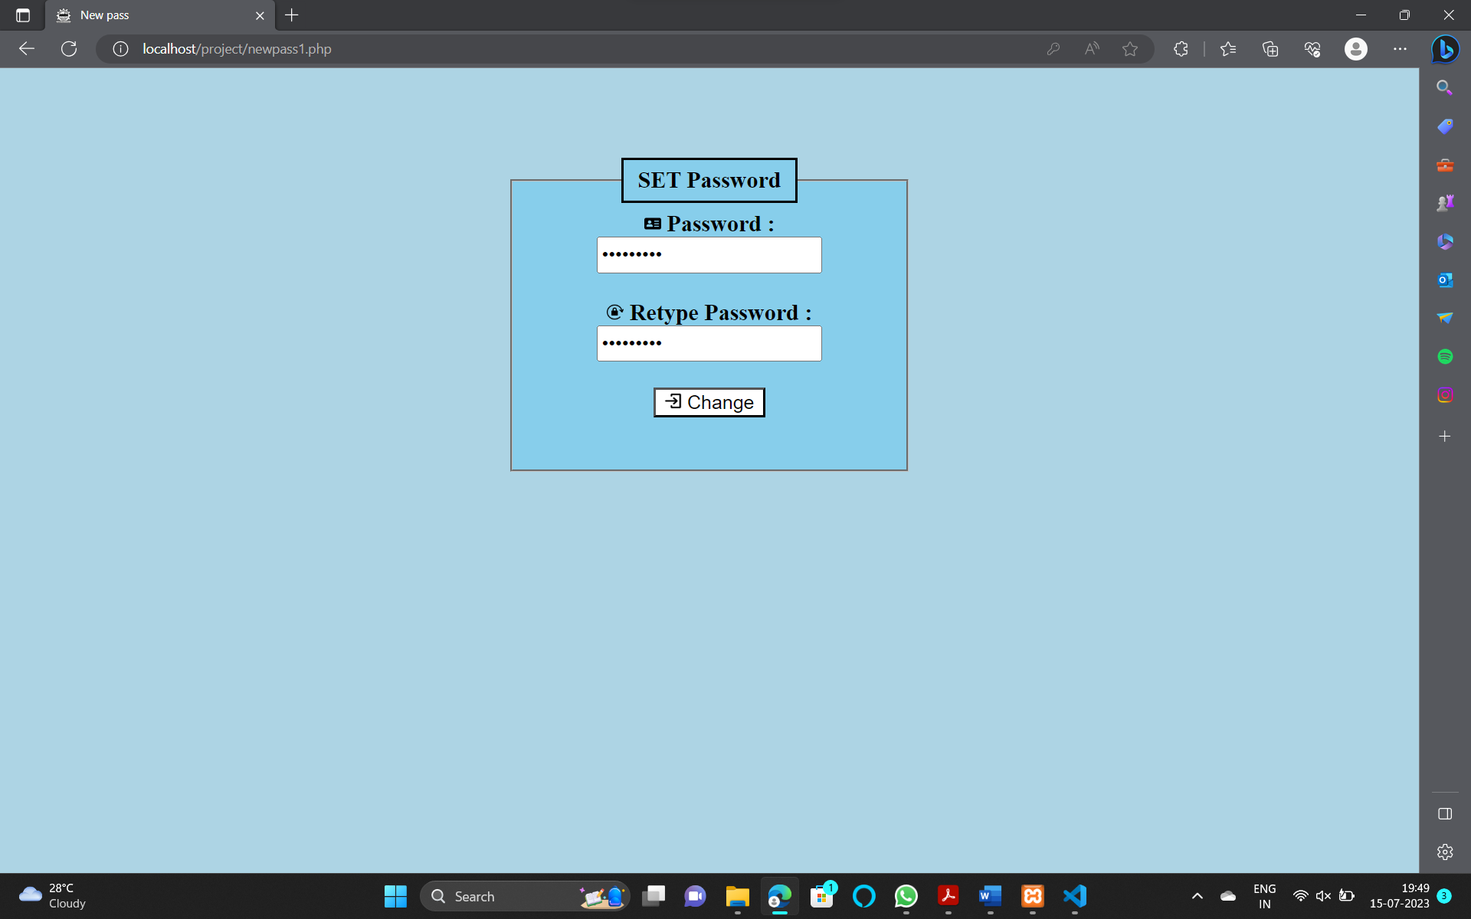

7) TO SET PASSWORD:

If the student is going to login for the first time the password will not be set initially you are allowed to set password by choosing Set password option in login page. After that an OTP verification is sent to your respective registered Email. After verification you are allowed to set password.

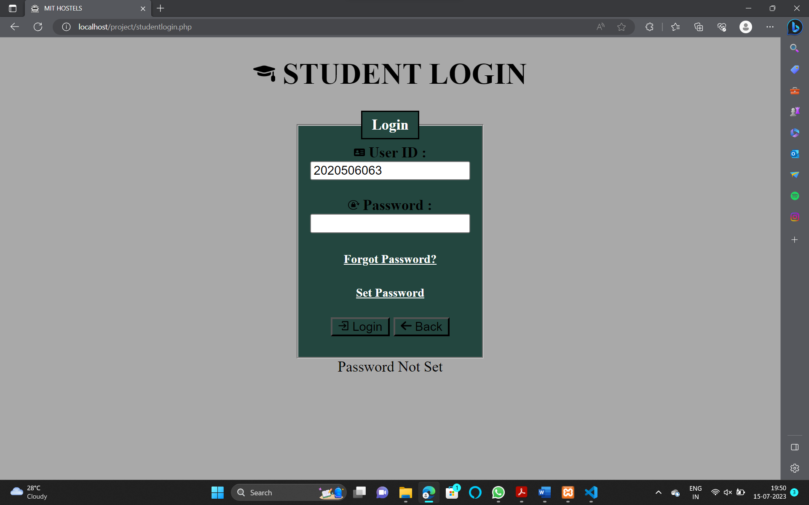

i) TO SET:

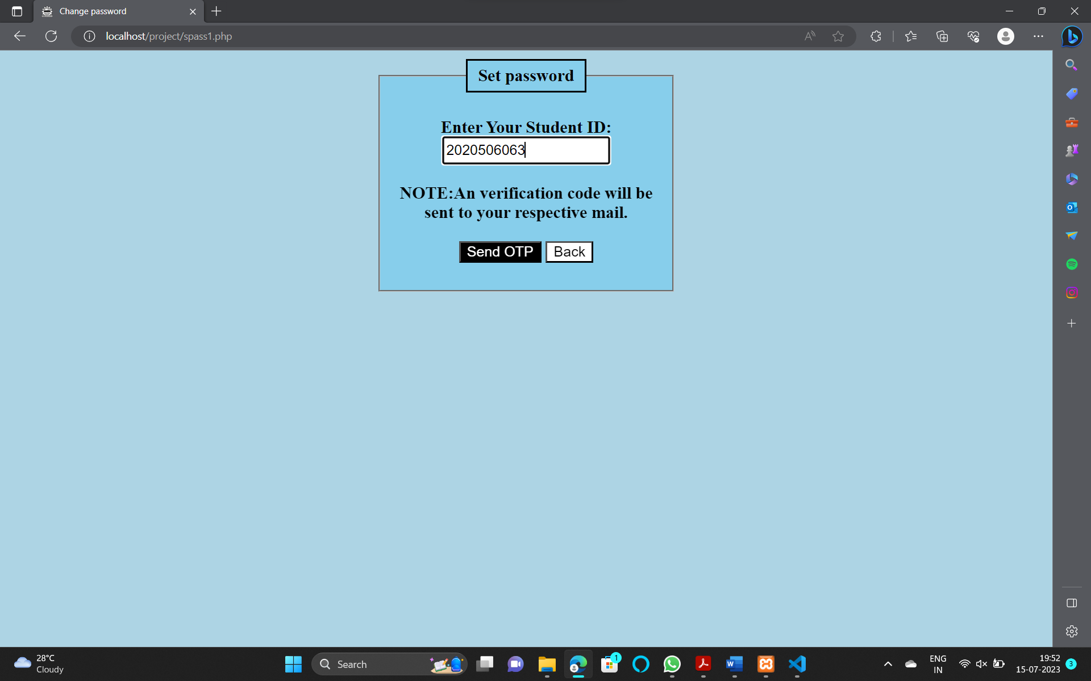

ii) OTP VERIFICATION:

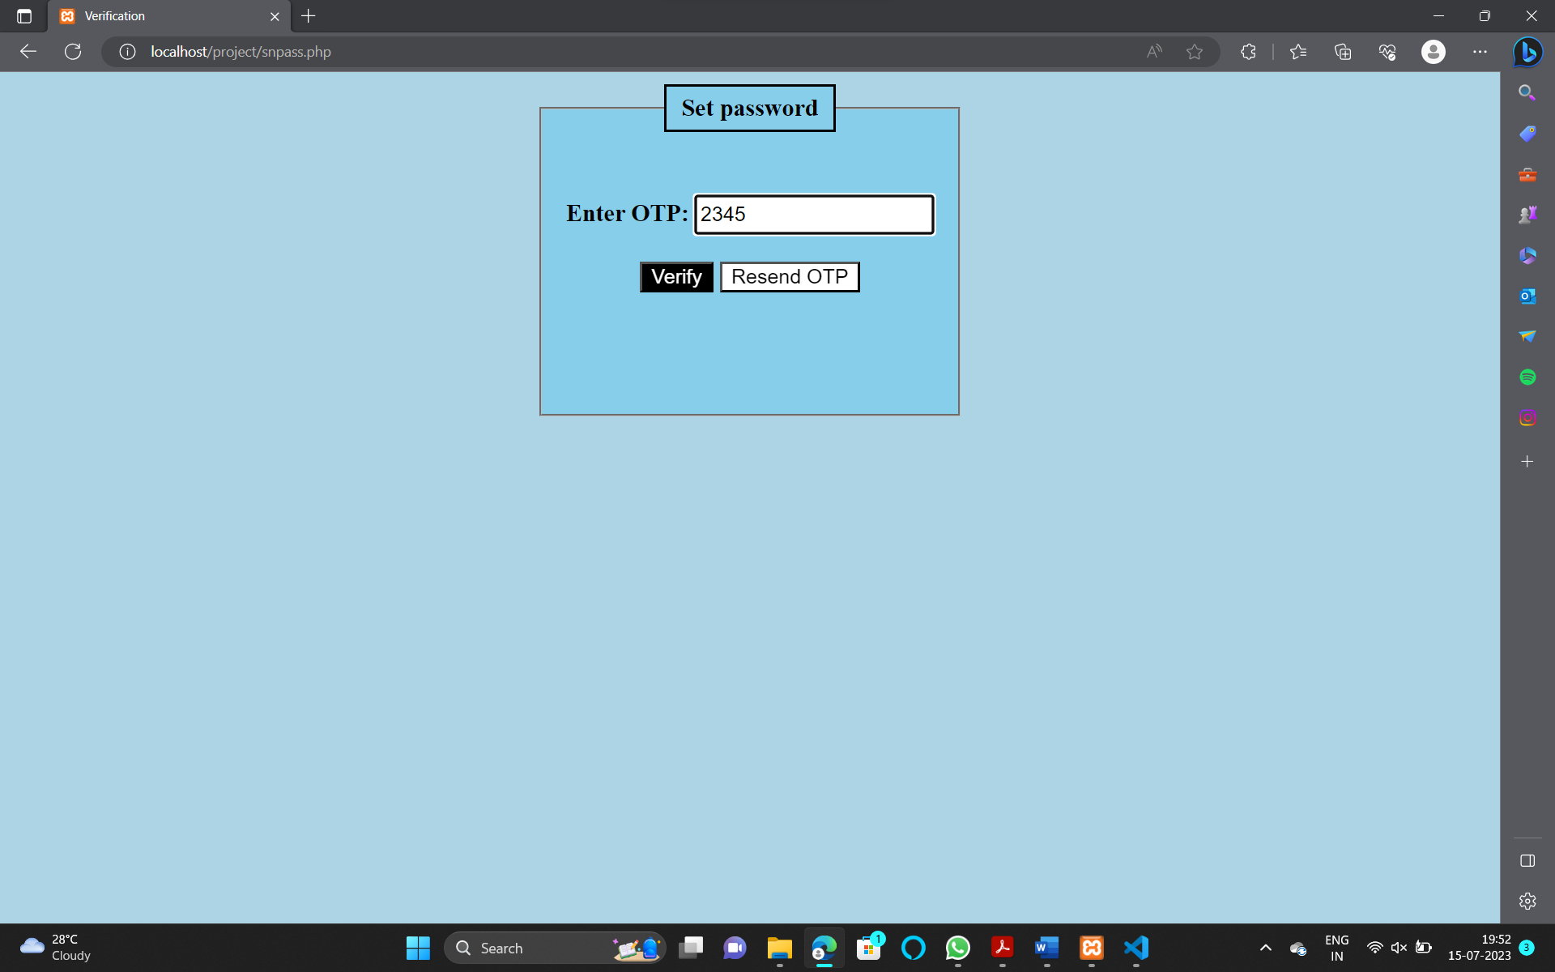

iii) SET PASSWORD:

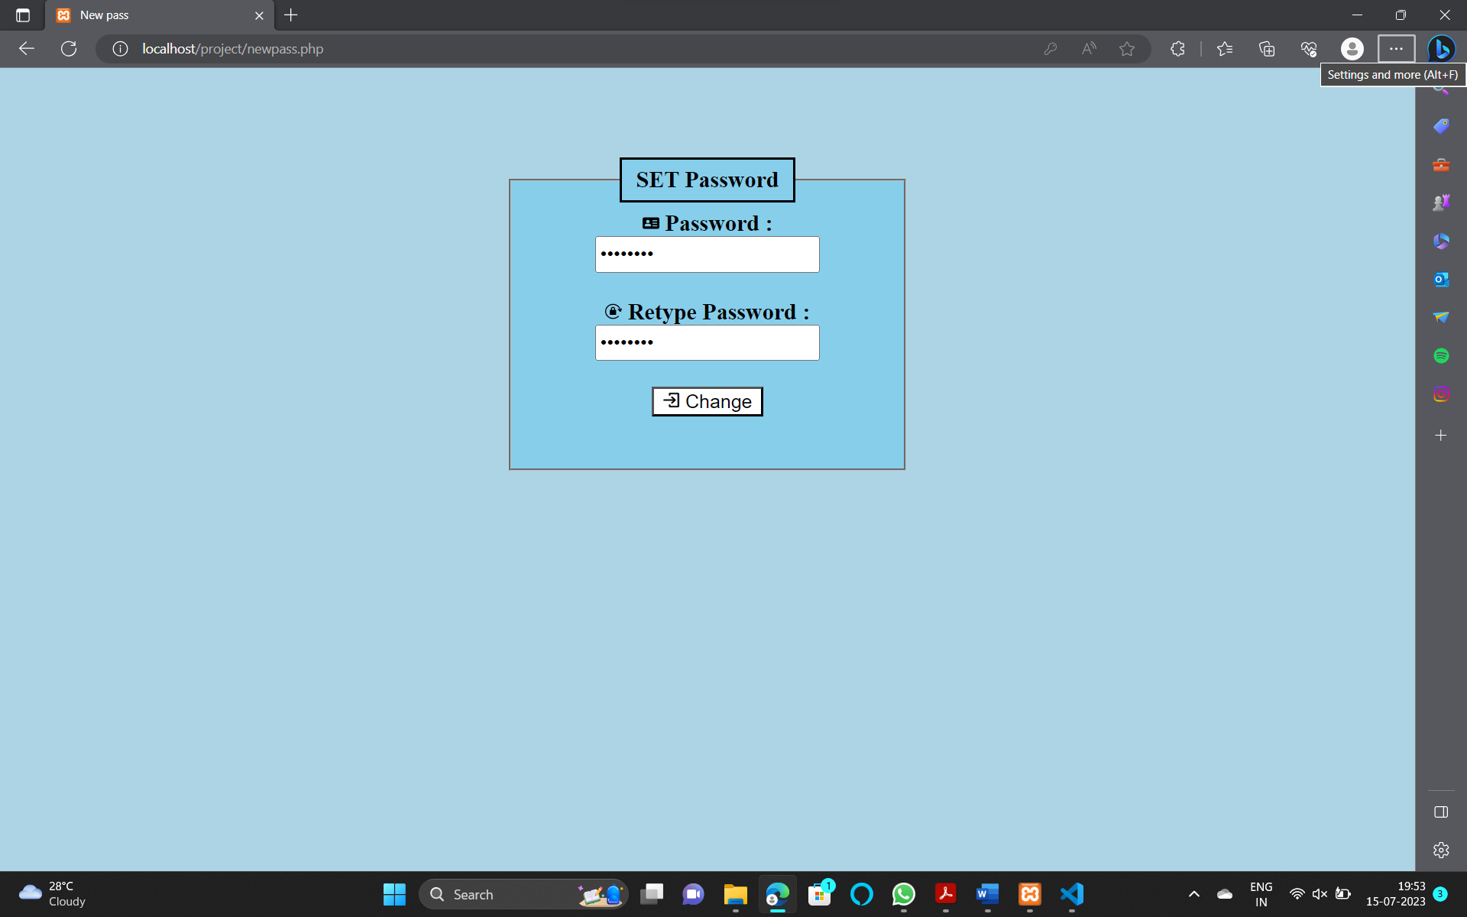

**CONCLUSION**:

The Hostel Store Online Booking System is a mini project that provides hostel residents with a convenient and user-friendly platform to order items from the hostel store. By leveraging technologies such as HTML, CSS, JavaScript, and PHP, the project offers features similar to popular online food delivery platforms like Zomato and Swiggy. The system's components, including the user interface, product catalog, user authentication, cart functionality, ordering and payment, and order tracking, work together to create a seamless and efficient user experience. With further enhancements and integrations, the system can be expanded to cater to the specific requirements of different hostels or establishments.